Sponsorship Opportunity

Guidance Document



March 2026

Causeway Coast and Glens Borough Council
Sponsorship Opportunity Guidance Document

Strategy Title | Sponsorship Opportunity Guidance Document
Version | V1
Summary | The purpose of this document is to provide clarity for partners/sponsors as to the requirements when undertaking to sponsor a roundabout / flowerbed site within Causeway Coast and Glens Borough Council
Source / Author | Estates Department
Next Review Date | March 2028
Officer Responsible for Review | Estates Manager

Revision History

Date | Changes Made | Version

Contents
1.0 Introduction 5
2.0 Purpose of the Agreement 6
3.0 Scope 6
4.0 Sponsorship Details 7
5.0 Decision-Making Process 9
6.0 Signage 10
7.0 Cost of Sponsorship 11
8.0 Breach of Agreement 11
9.0 Monitoring, Evaluation and Review 11
10.0 Definition of Terms 12
11.0 Appendix 1.0 – List of Available Sites 13
12.0 Site A1 – Flowerbed at Old Courthouse, Coleraine 14
13.0 Site A2 – Flowerbed on Castlerock Road at Coleraine Grammer 15
14.0 Site A3 – Flowerbed at the Library, Coleraine 16
15.0 Site A4 – Flowerbed at the Boulevard, Coleraine 17
16.0 Site A5 – Flowerbed at the Rose Gardens, Coleraine 18
17.0 Site A6 – Roundabout at Ballycastle Road, Coleraine 19
18.0 Site A7 – Roundabout at Lodge Road, Coleraine 20
19.0 Site A8 – Roundabout at Bushmills Road, Coleraine 21
20.0 Site A9 – Roundabout at Wattstown Crescent, Coleraine 22
21.0 Site A10 – Greenmount Roundabout, Coleraine 23
22.0 Site A11 – Strand Road Roundabout, Coleraine 24
23.0 Site A12 – Burnside Road Roundabout, Portstewart 25
24.0 Site A13 – Church Street Roundabout, Kilrea 26
25.0 Site A14 – Ballybogey Road Roundabout, Ballymoney 27
26.0 Site A15 – Kilraughts Road Roundabout, Ballymoney 28
27.0 Site A16 – Flowerbed on Coleraine Road, Ballymoney 29
28.0 Site A17 – Edenmore Road Roundabout, Limavady 30
29.0 Site A18 – Main Street Roundabout, Limavady 31
30.0 Site A19 – Scroggy Road Roundabout, Limavady 32
31.0 Site A20 – Lisnakelly Roundabout, Limavady 33
32.0 Site A21 – Aghanloo/Windyhill Rd Roundabout, Limavady 34
33.0 Site A22 – Aghanloo/Artikelly Rd Roundabout, Limavady 35
34.0 Site A23 – Broad Road Roundabout, Limavady 36
35.0 Site A24 – Flowerbed at Chapel Road, Dungiven 37
36.0 Site A25 – Ballyclose Street Roundabout, Limavady 38
37.0 Site A26 – Flowerbed at Bells Hill, Limavady 39

Introduction

  - Across Causeway Coast and Glens Borough Council (CCGBC), the Estates Management Team have been working closely with our own biodiversity team as well as external input to improve the biodiversity of our planting regimes. Attracting sponsorship from third party organisations is another way to have community inclusion in biodiversity projects which will assist in allowing CCGBC to improve the biodiversity of plants and trees across the borough.

  - Roundabouts and flowerbeds within the Borough are owned and controlled by the Department for Infrastructure (DFI). While the DFI has a statutory duty to maintain roundabouts and roadside verges, in some circumstances local Councils are willing to undertake this function on the DFI’s behalf. Causeway Coast and Glens Borough Council currently complete this function, maintaining roundabouts and flowerbeds within the Borough. The guidance for the private funding and maintenance of roundabouts is set out in the DFI’s guidance document RSPPG E004.

  - All sponsorship sites are listed within Appendix 1.0 of this document. All sites should be reviewed by the applicant prior to submission of completed application.

  - Applicants should include only 1no. site per application form.

  - Applications for Roundabout / Flowerbed Sponsorships must be submitted to estatesprocurement@causewaycoastandglens.gov.uk by no later than 12:00 Noon Friday 27th March 2025.

Applications received after this Deadline will not be considered.

  - The Client and Contact for this is:

Contact: Estates Department

Telephone: +44 (0) 28 2766 0227

Email: estates.helpdesk@causewaycoastandglens.gov.uk

Address: Causeway Coast & Glens Borough Council,
Estates Department,
Riada House,
14 Charles Street,
Ballymoney,
BT53 6DZ,
Northern Ireland

- Purpose of the Agreement

  - The purpose of this document is to provide clarity for businesses / organisations as to the requirements when undertaking to sponsor a roundabout / flowerbed within Causeway Coast and Glens Borough Council.

- Scope

  - For the purposes of this guidance document the public areas covered include the following as also included within the application document:

- Roundabout junctions

- Flowerbeds

  - All sponsorship sites are listed within Appendix 1.0 of this document. All sites should be reviewed by the applicant prior to submission of completed application.

- Sponsorship Details

  - Who can sponsor a roundabout / flowerbed?
- Causeway Coast and Glens Borough Council will consider requests to sponsor roundabouts / flowerbeds from any charitable organisation, community group or commercial enterprise.

  - Benefits of Sponsorship
- Increase awareness of your organisation, highlighting your presence in the local community.
- Convey a positive image of your business by supporting a scheme that is enhancing the local environment for residents and visitors.
- Compatible with Corporate Social Responsibility objectives of your organisation.
- Coverage is for 365 days of the year, 24 hours per day, acting as a constant reminder to residents and visitors to Causeway Coast and Glens Borough Council.
- Thousands of vehicles pass each location every year.
- Additional PR opportunities exist with local media.
- Provides the rare opportunity to place your organisation name on the public highway.
- Exclusivity with only one organisation per site.

  - Sites that may be sponsored
Not all roundabouts are suitable for sponsorship. Council’s decision on suitability of sites is final as decisions will be made by staff on safety grounds in consultation with DFI.

  - Limitations of Sponsorship
Please note that roundabout sponsorship is not available for the following types of products, services, businesses and organisations:
- sponsorship which may be construed as showing or encouraging any type of prejudice (e.g. racial, sexual or religious).
- political organisations or messages.
- sponsorship which is not considered to comply with the guidelines set down from time to time by the Advertising Standards Authority (ASA).
- sponsorship for products of, or companies dealing in, the Tobacco Industry.
- sponsorship for alcohol or alcoholic drinks.
- any other sponsorship type deemed inappropriate by Council or DFI.

  - The successful sponsor cannot transfer or “sub-let” the sponsorship space on the roundabout/flowerbed. In the event that the sponsor ceases to trade or fails to pay the annual sponsorship fee the Council will remove signage and seek an alternative sponsor for the roundabout/flowerbed.

  - The locations are available for a set period of two-year sponsorship. These are invoiced annually.

- Decision-Making Process

  - Sponsorship opportunities will be advertised via councils website

  - Potential sponsors must submit applications with signed agreement, before the deadline and setting out their bid.

  - An award notification will be issued to the winning bidder.

  - After award, the successful bidder will be responsible for supplying the final, correct digital file required for production of the sign

- Signage

  - Council will supply the sign with the final proof confirmed before production of the sign(s).

  - The dimensions of the signs are: 750mm x 400mm maximum

  - The incentive for sponsorship will be approval for the placement of signs within highway limits. The size and number of signs will be as per the Applications and in connection with the requirements of RSPPG 004.

  - Additional signage or information is NOT ALLOWED to be added/or bolted to the signs and these will be removed at your cost if you decide to add to the 750mm x 400mm maximum signage afterwards.

  - For reasons of Health and Safety, signs can only be installed, maintained and removed by council staff. Sponsors are responsible for the cost of replacement signs, damaged, by third parties.

  - Sponsorship signs will include “in partnership with Causeway Coast & Glens Borough Council” in signage footer as per visual below.

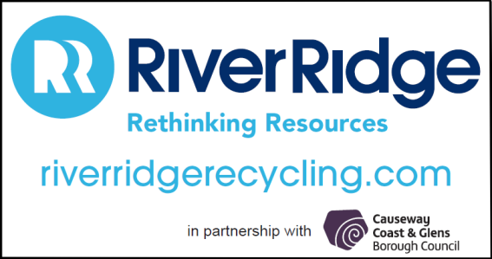

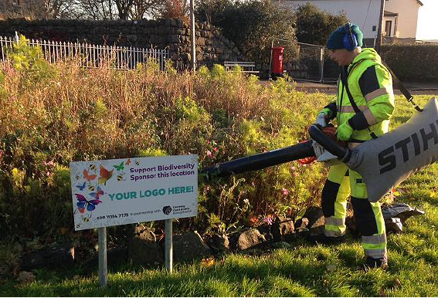

- Cost of Sponsorship

  - Guide values will be set for the sponsorship of each site. This will depend on the location and size of the roundabout/flowerbed, as well as the traffic volume on the road on which the roundabout/flowerbed is located. However, due to the bidding process, potential sponsors may go in with higher or lower offers.

  - Officers will always seek to achieve best value for ratepayers each time a new sponsor is sought.

  - Sponsors will be invoiced annually each year of the agreement (unless sponsorship has been commenced mid-year). Failure to pay within 28 days may constitute a breach of agreement (see below) and may result in termination of the sponsorship agreement.

- Breach of Agreement

  - In the event of a breach of agreement Council Officers will endeavor to resolve the issues behind it. Where this fails, Council will seek to terminate the agreement.

  - Temporary removal of sponsorship signs for highway purposes will not constitute a breach of agreement by Council.

  - Any activity undertaken by a sponsor that endangers highway users will be considered a serious breach of agreement. Council will investigate any such instances and as a result may terminate the agreement immediately.

  - Up to two written warnings may be given for lesser infractions before Council may opt to terminate the agreement (e.g. late payments).

  - Any person or group that habitually makes late payments (where funds are not with Council within 28 days of the invoice date) will be considered in breach of the agreement.

- Monitoring, Evaluation and Review

  - This guidance will be reviewed every two years, or sooner should there be a change to Department for Infrastructure guidance RSPPG E004.

- Definition of Terms

  - Council – Causeway Coast & Glens Borough Council.

  - Roundabout – A road junction in which traffic streams circulate around a central island that forms part of the highway.

  - Flowerbed – a decorative planted display bed arranged with flowers, shrubs, or decorative plants for visual appeal to create an attractive focal point

  - Sponsor / Sponsorship – Where an individual or group that makes financial payment per annum to the Council to sponsor their business or organisation at council chosen sites.

  - Agreement – A properly executed and legally binding contract.

  - Term of Agreement – Period of time to which parties to the agreement will be bound (two years).

- Appendix 1.0 – List of Available Sites

- Site A1 – Flowerbed at Old Courthouse, Coleraine

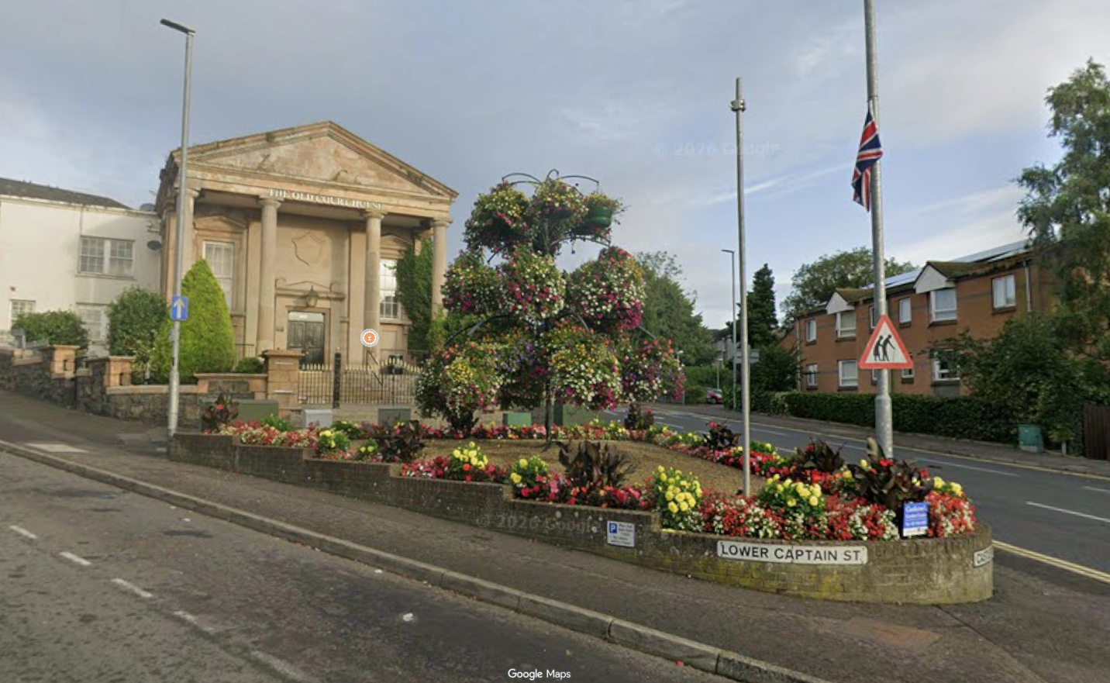

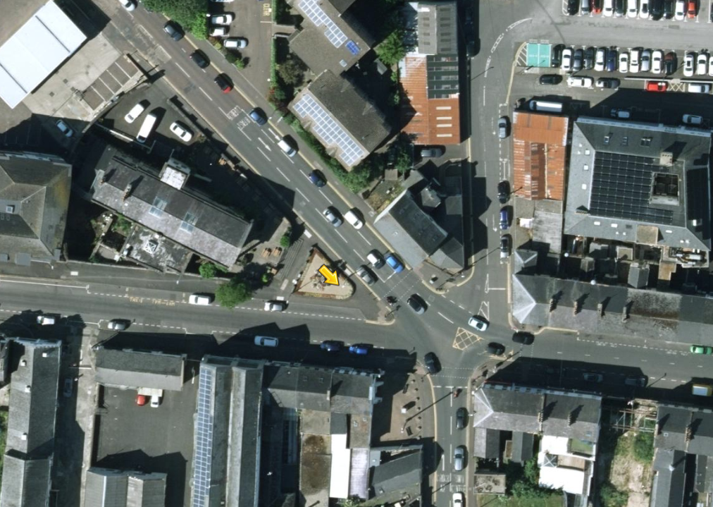

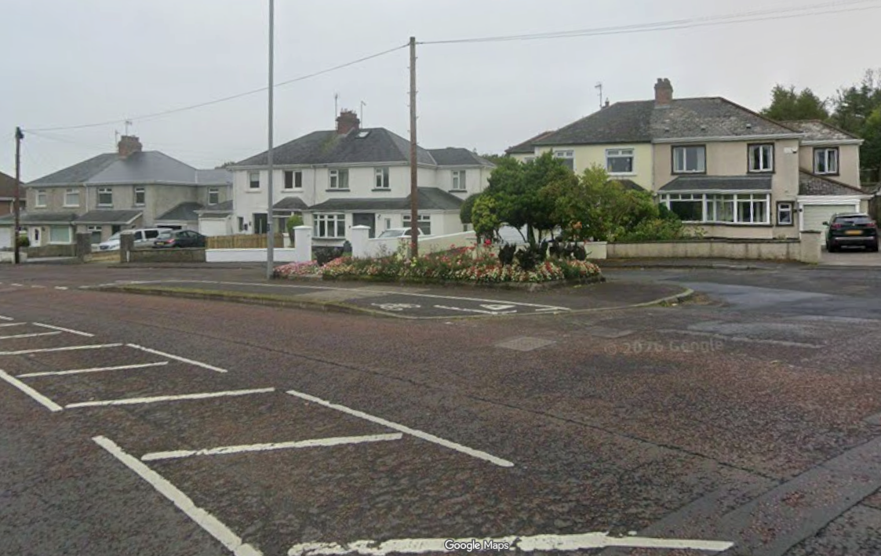
- Site A2 – Flowerbed on Castlerock Road at Coleraine Grammer

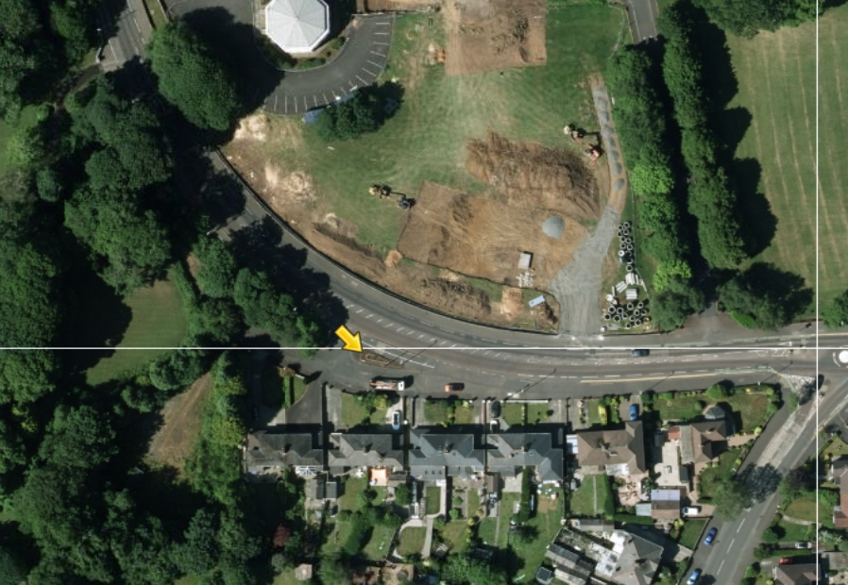

- Site A3 – Flowerbed at the Library, Coleraine

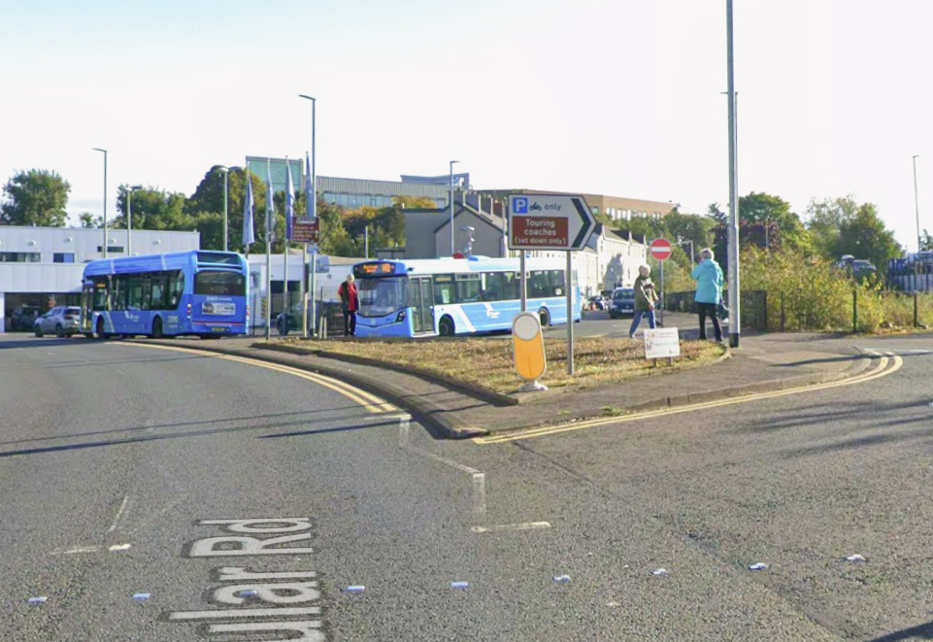

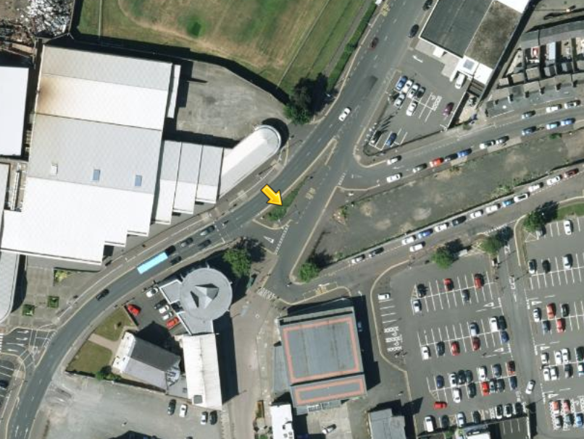

- Site A4 – Flowerbed at the Boulevard, Coleraine

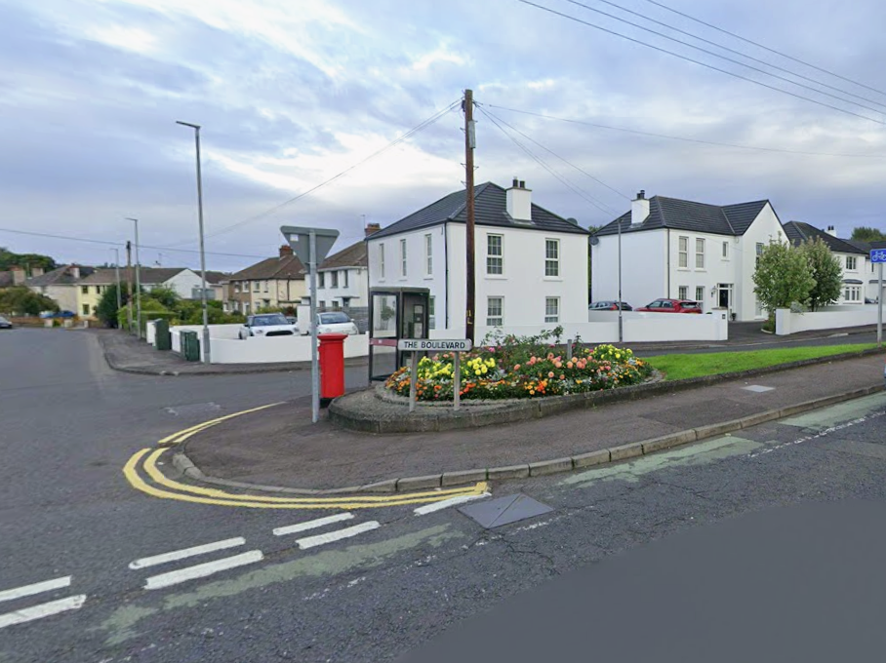

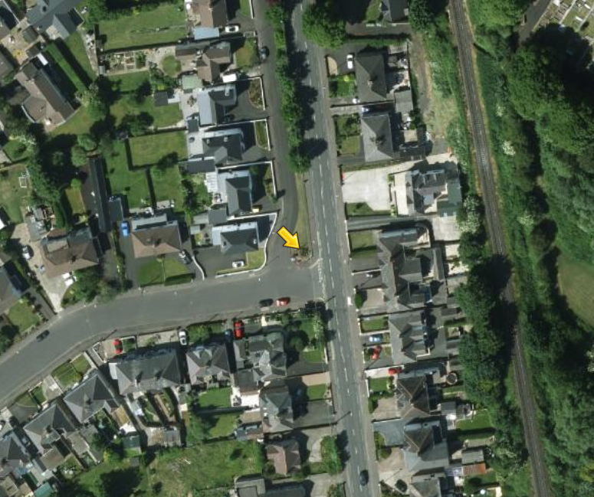
- Site A5 – Flowerbed at the Rose Gardens, Coleraine

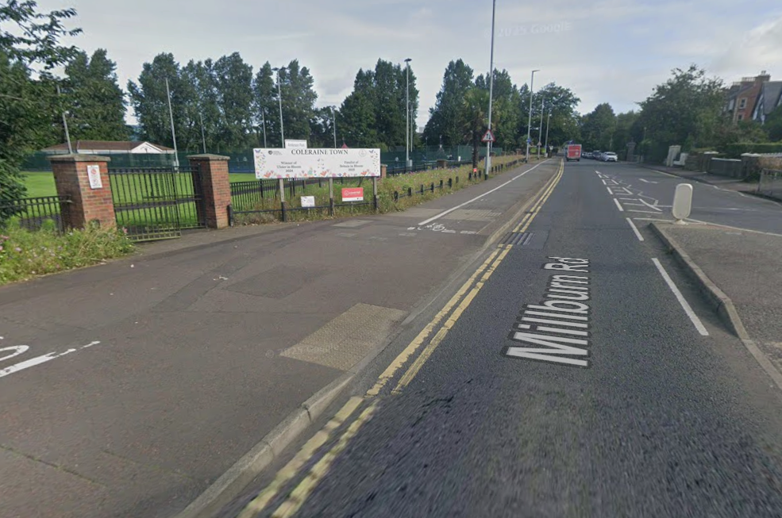

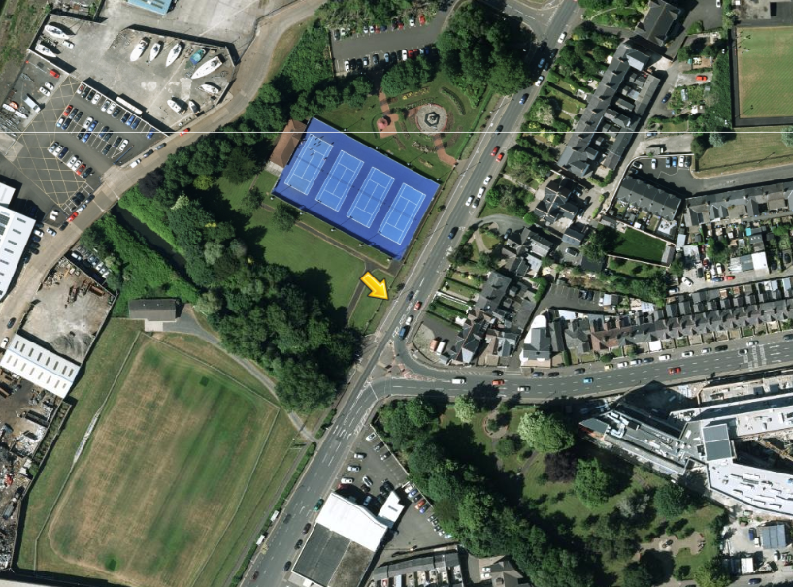

- Site A6 – Roundabout at Ballycastle Road, Coleraine

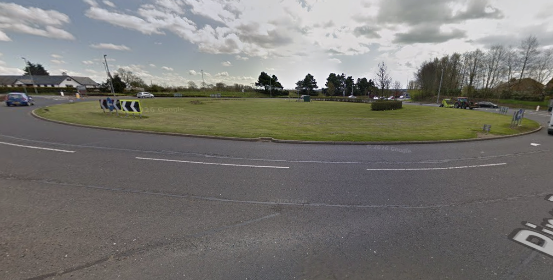

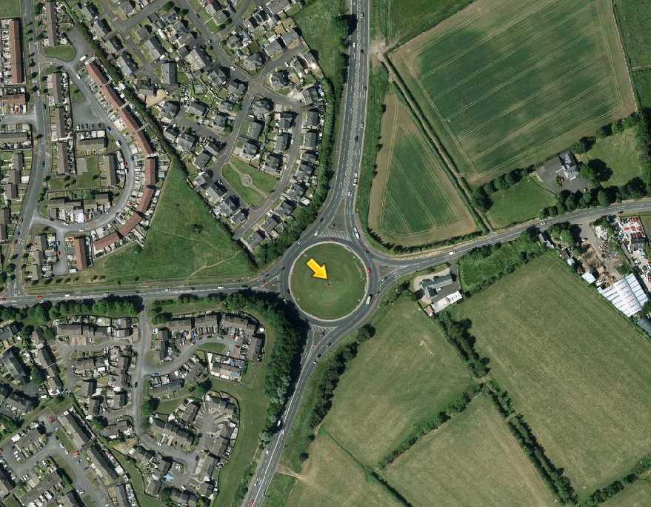

- Site A7 – Roundabout at Lodge Road, Coleraine

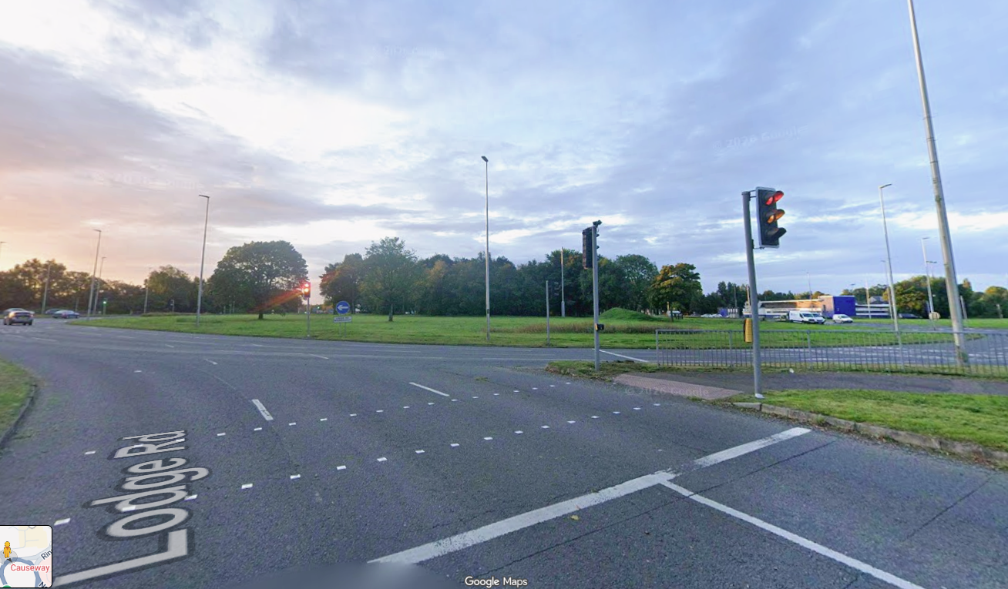

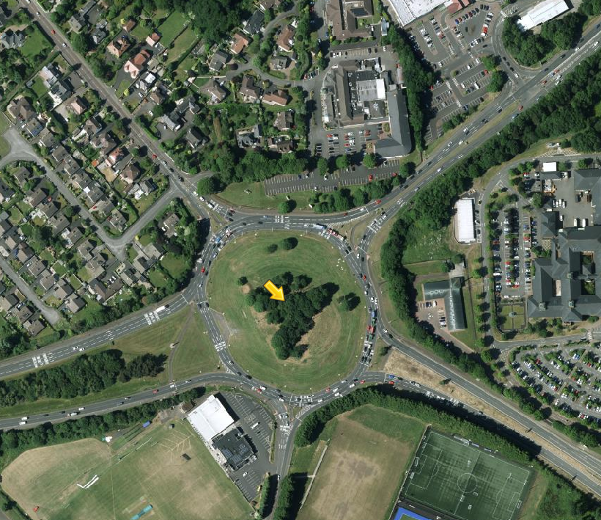

- Site A8 – Roundabout at Bushmills Road, Coleraine

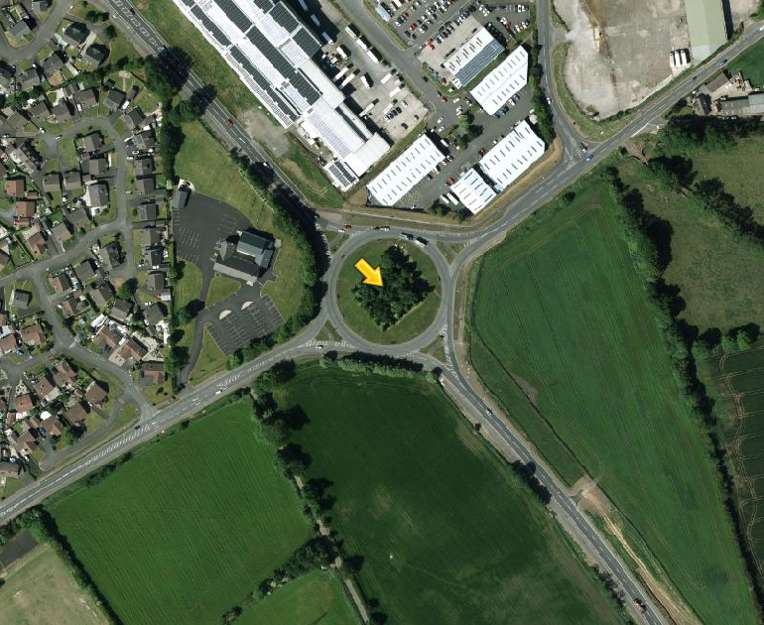
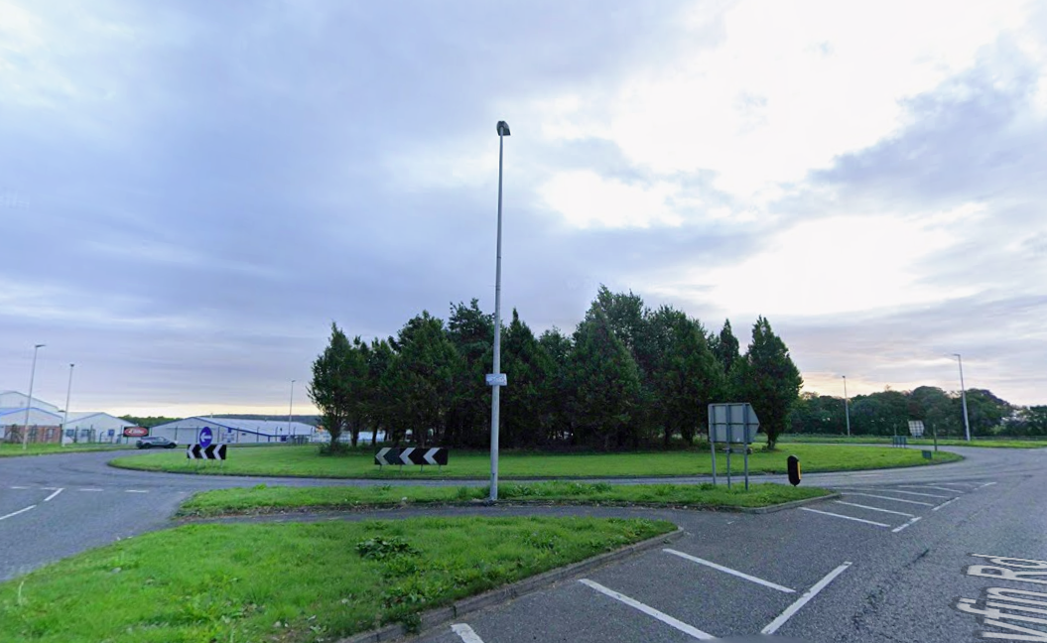

- Site A9 – Roundabout at Wattstown Crescent, Coleraine

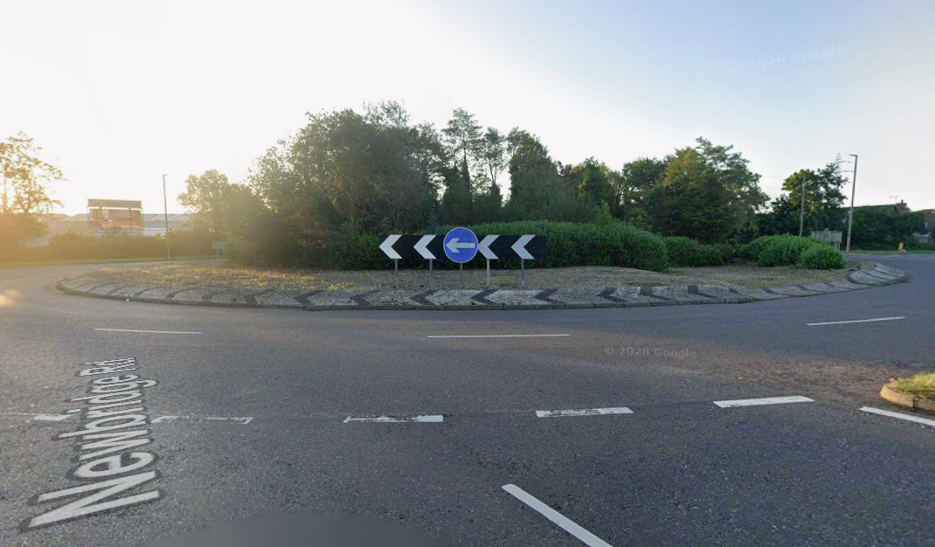
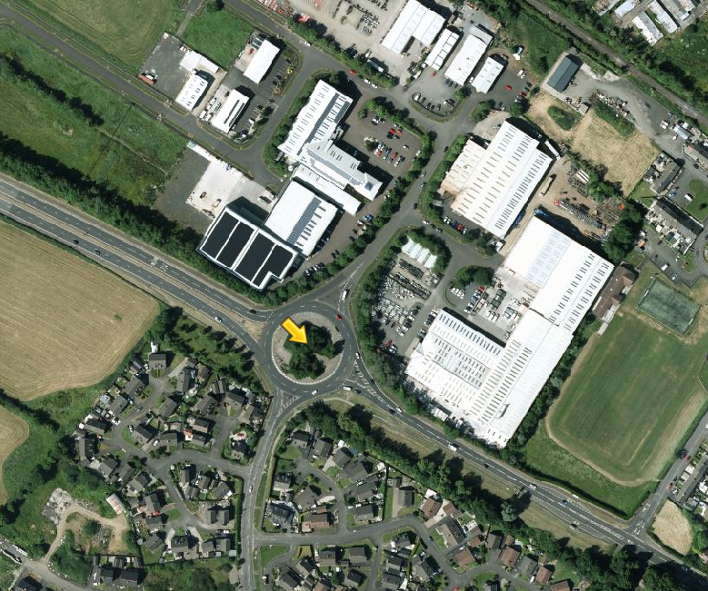

- Site A10 – Greenmount Roundabout, Coleraine

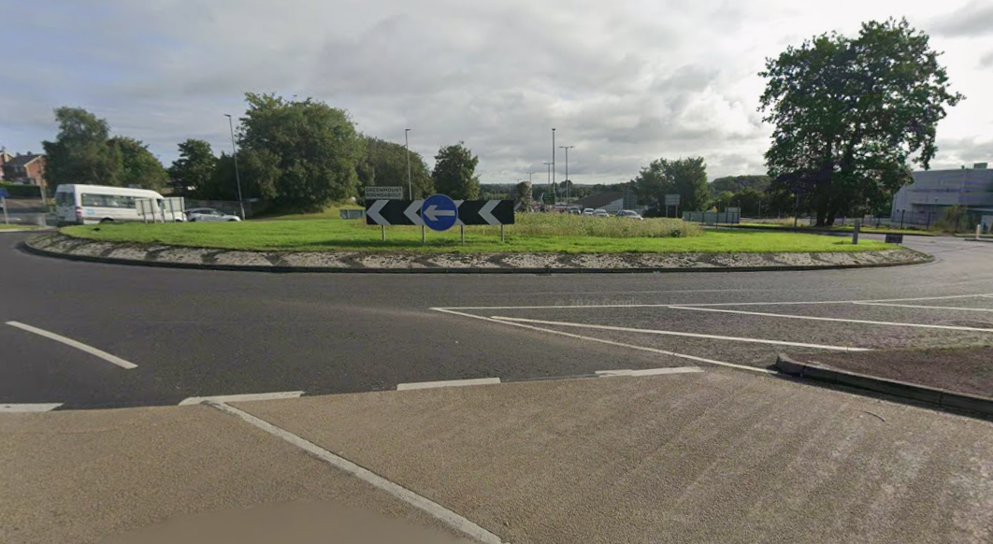

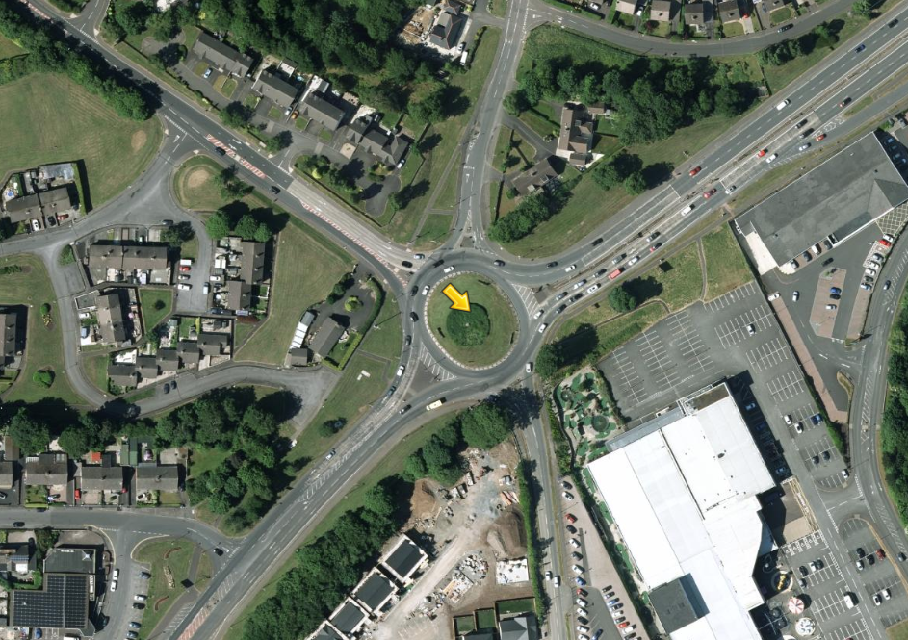

- Site A11 – Strand Road Roundabout, Coleraine

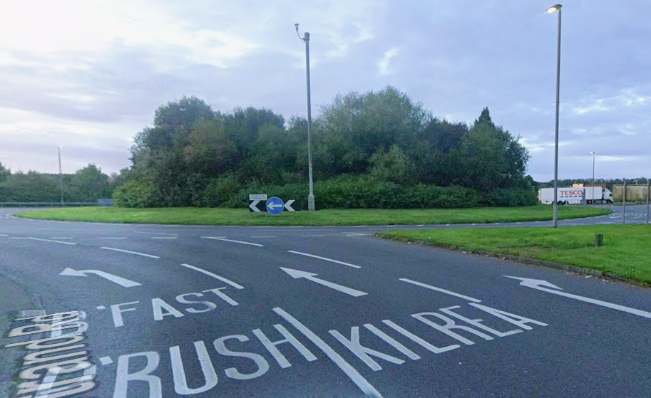

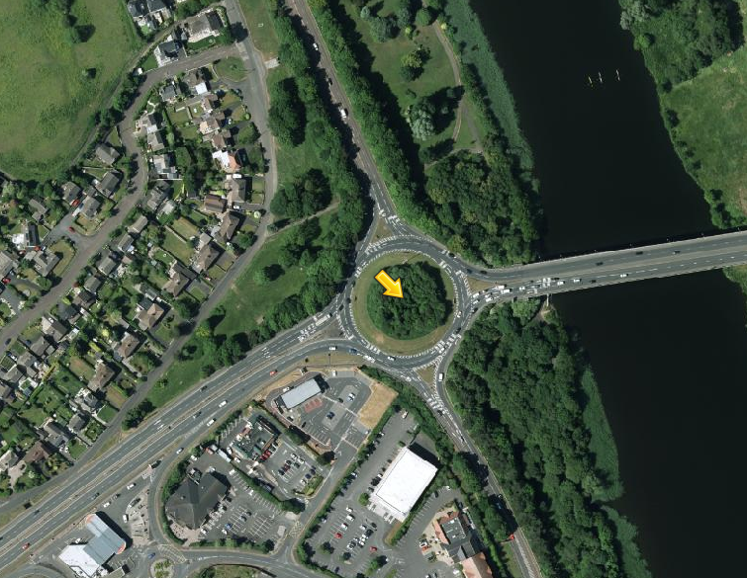

- Site A12 – Burnside Road Roundabout, Portstewart

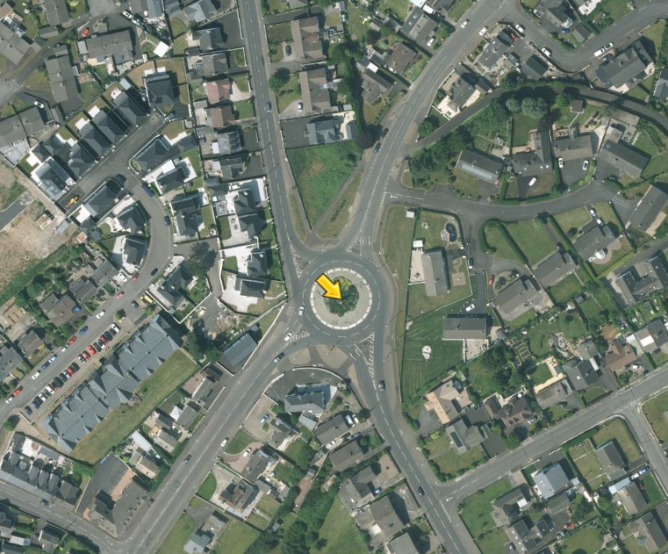
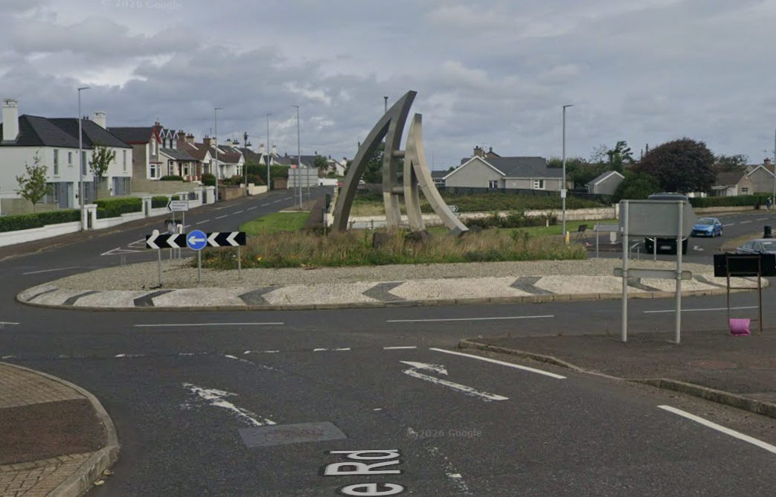
- Site A13 – Church Street Roundabout, Kilrea

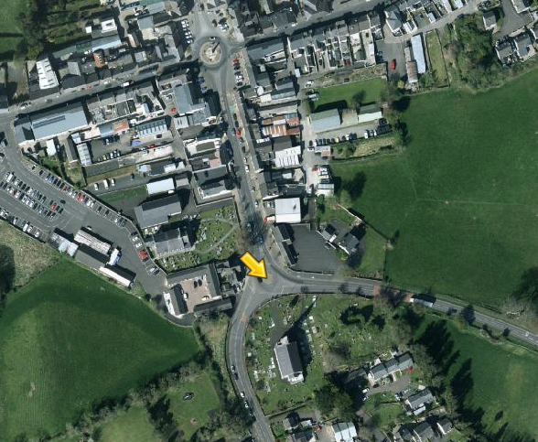
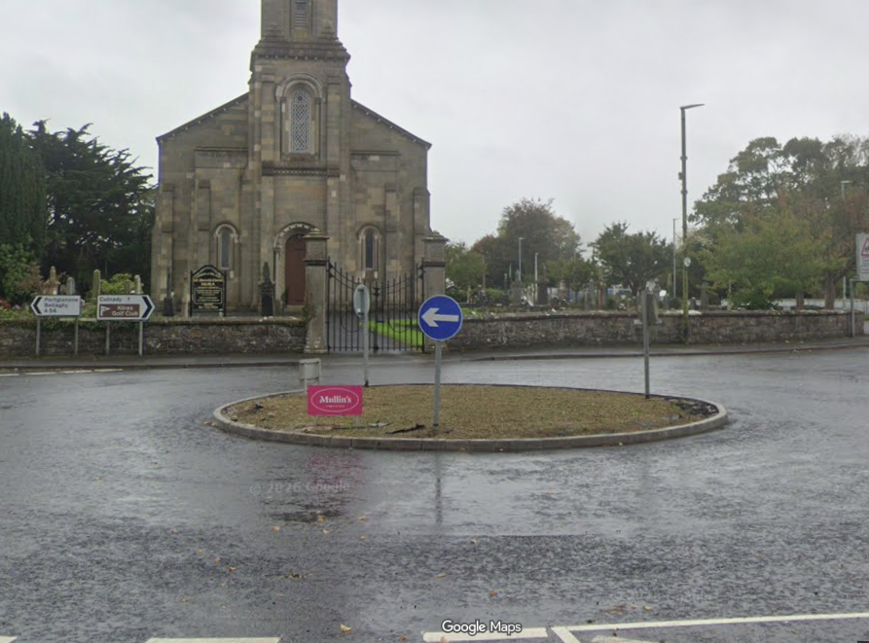
- Site A14 – Ballybogey Road Roundabout, Ballymoney

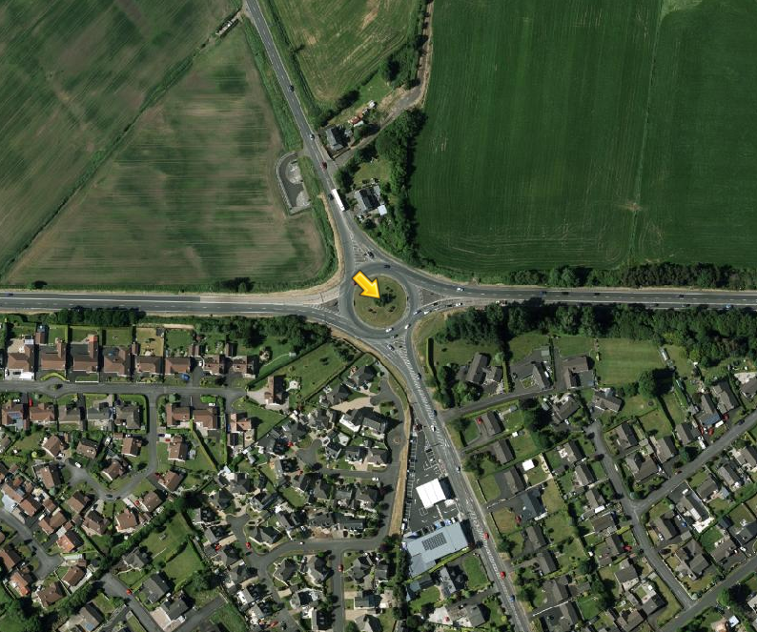
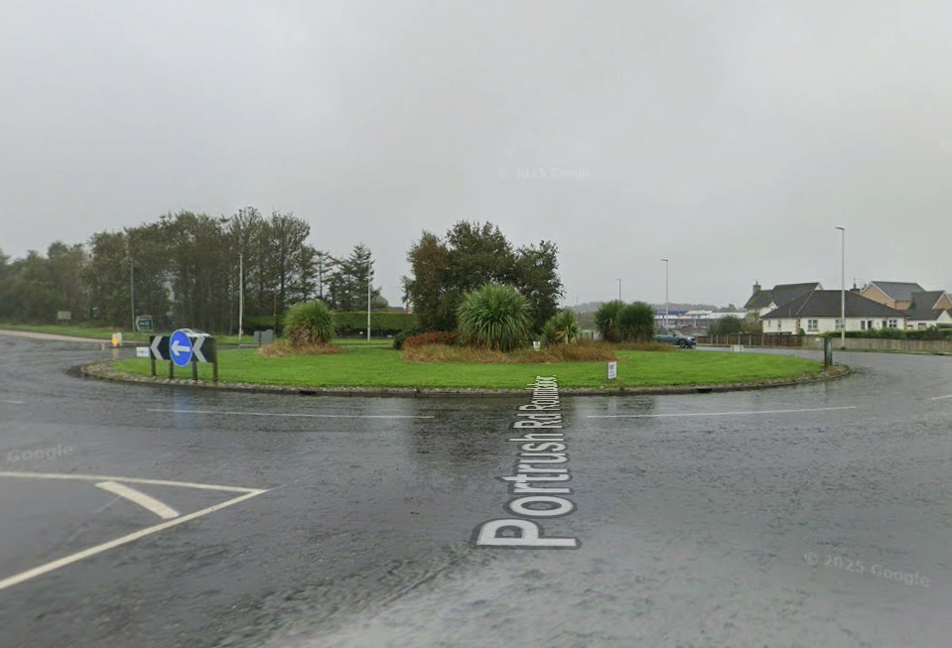
- Site A15 – Kilraughts Road Roundabout, Ballymoney

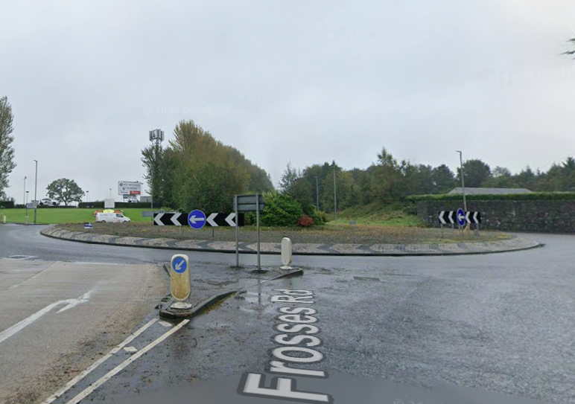

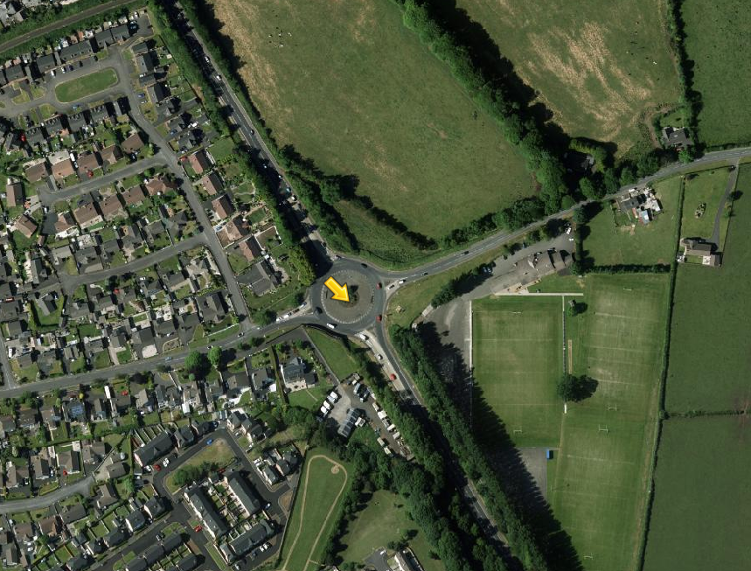
- Site A16 – Flowerbed on Coleraine Road, Ballymoney
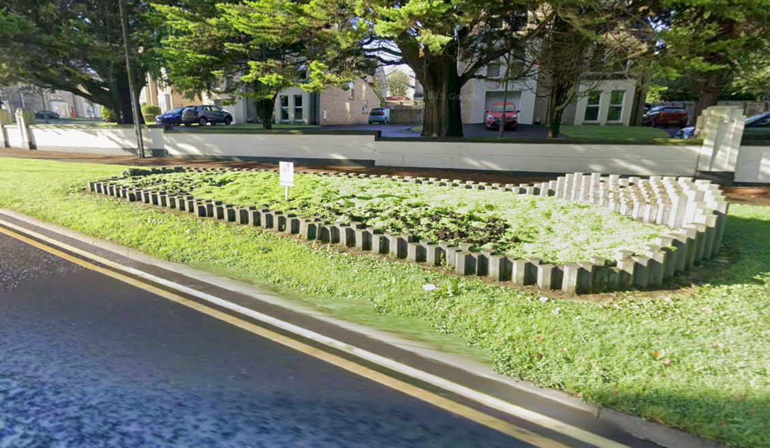
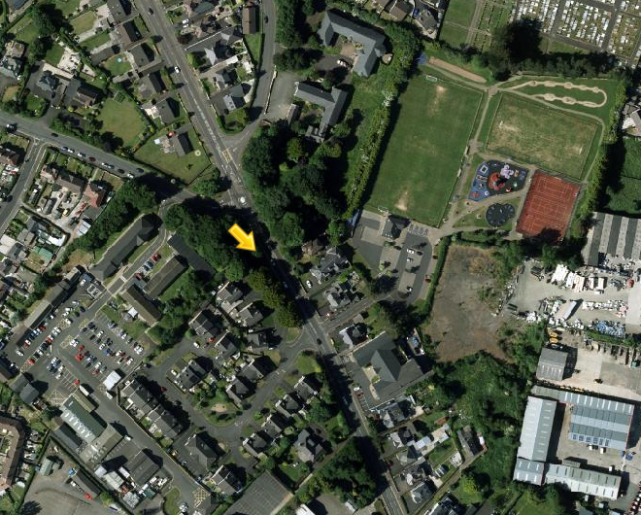
- Site A17 – Edenmore Road Roundabout, Limavady
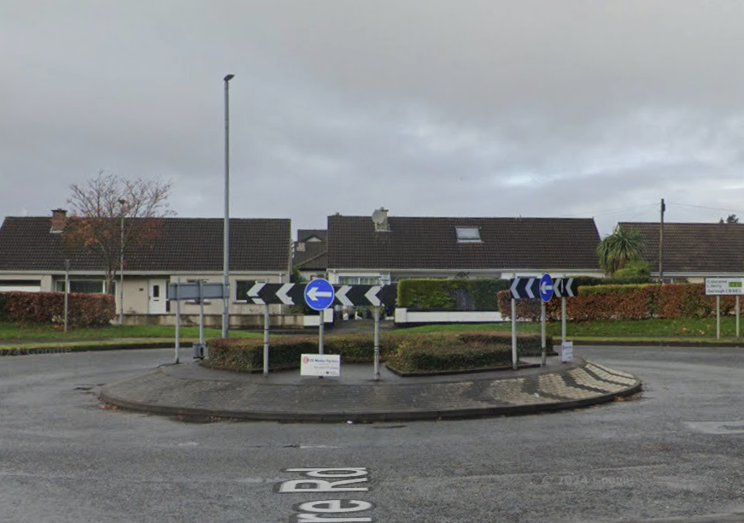
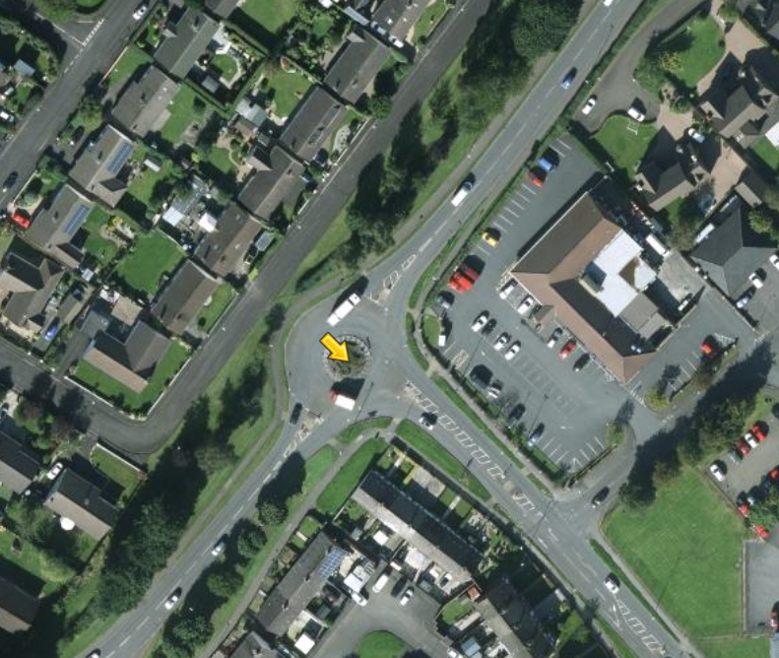
- Site A18 – Main Street Roundabout, Limavady

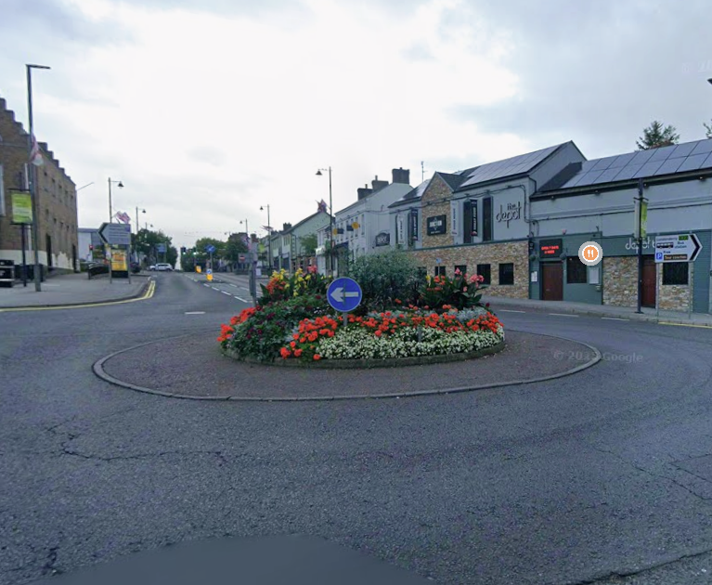

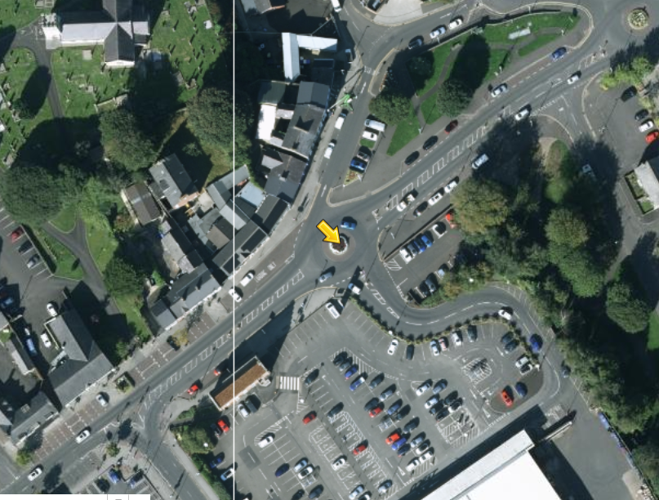
- Site A19 – Scroggy Road Roundabout, Limavady

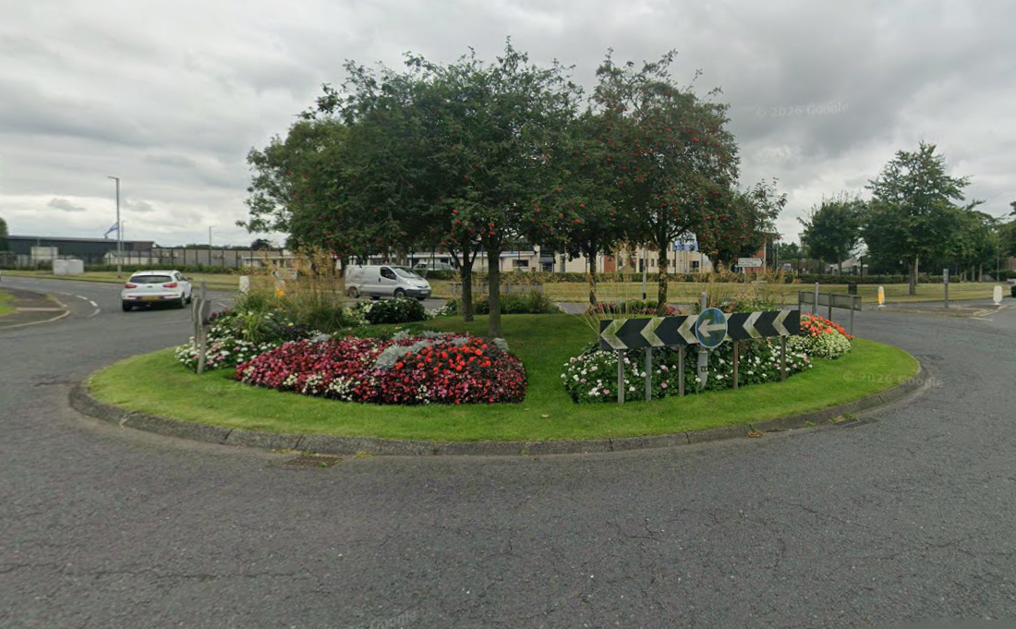
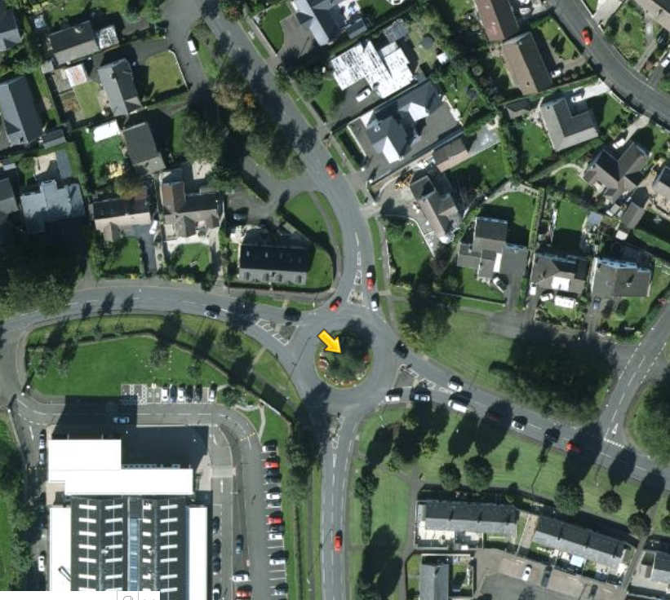
- Site A20 – Lisnakelly Roundabout, Limavady

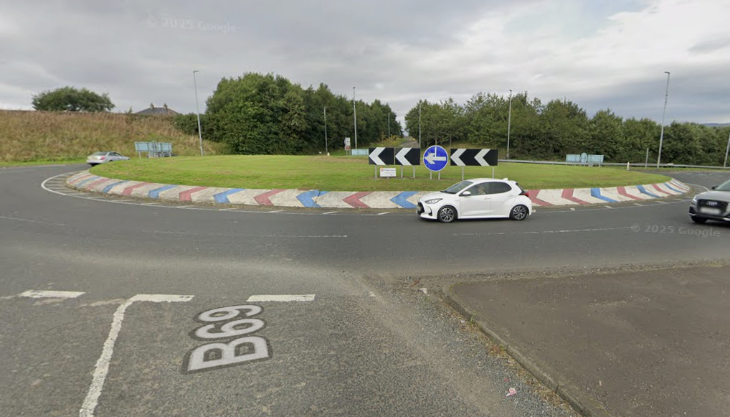

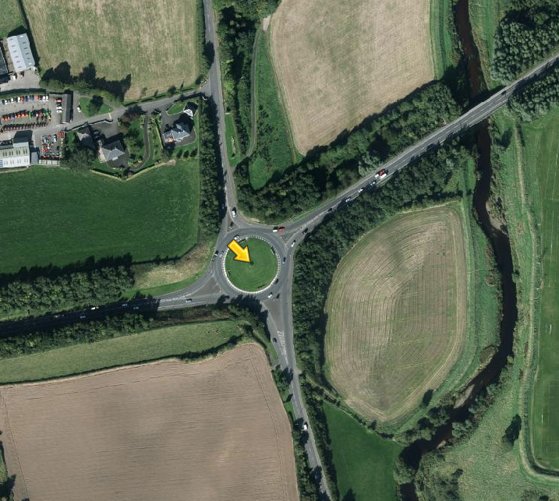

- Site A21 – Aghanloo/Windyhill Rd Roundabout, Limavady

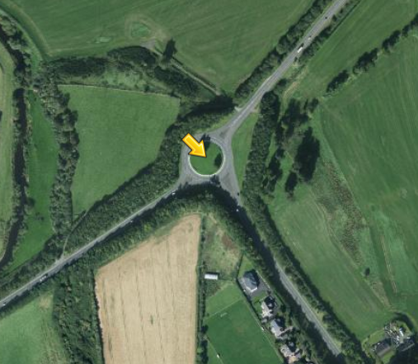
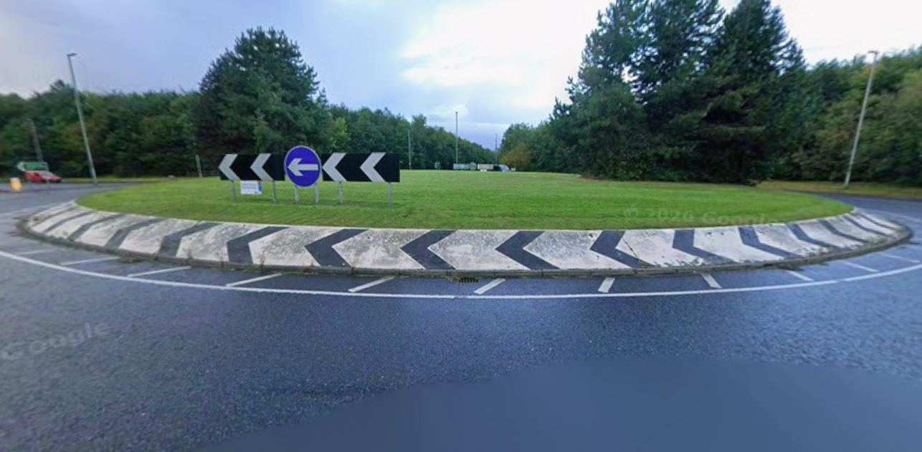

- Site A22 – Aghanloo/Artikelly Rd Roundabout, Limavady

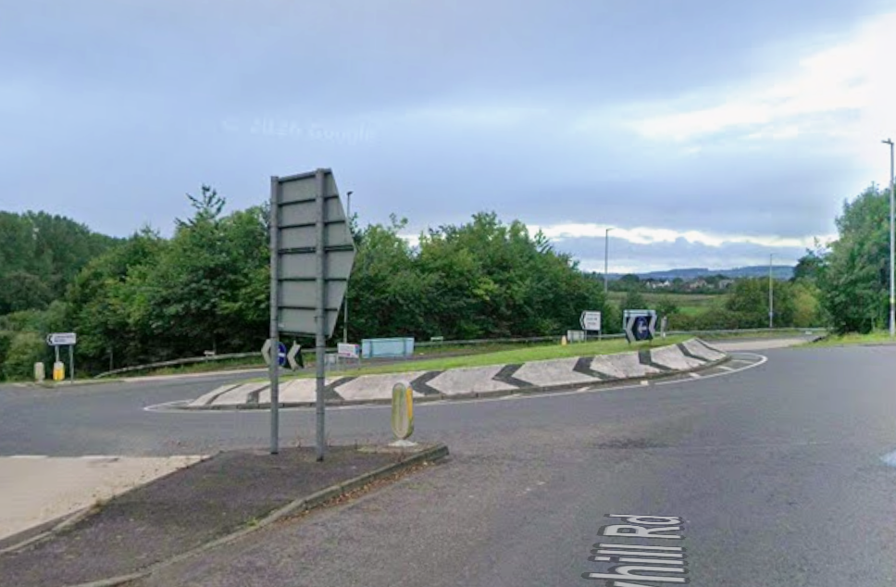

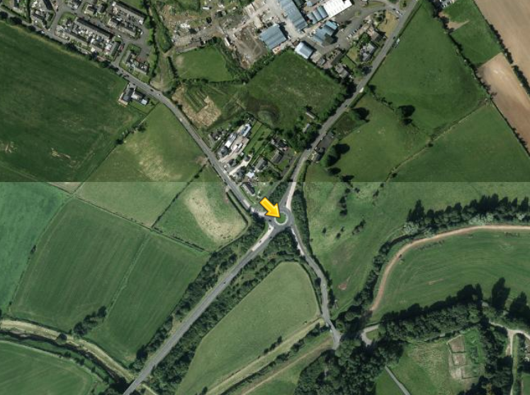

- Site A23 – Broad Road Roundabout, Limavady

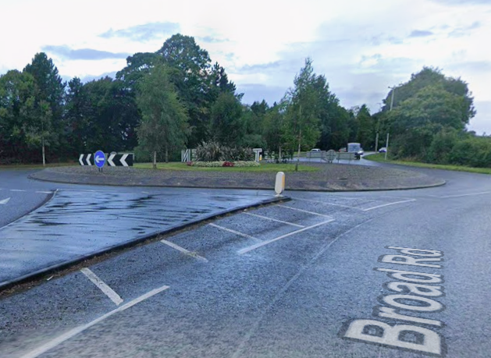

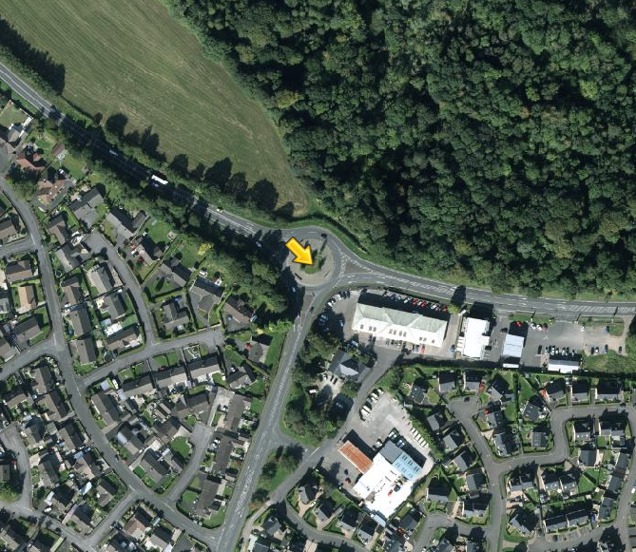

- Site A24 – Flowerbed at Chapel Road, Dungiven

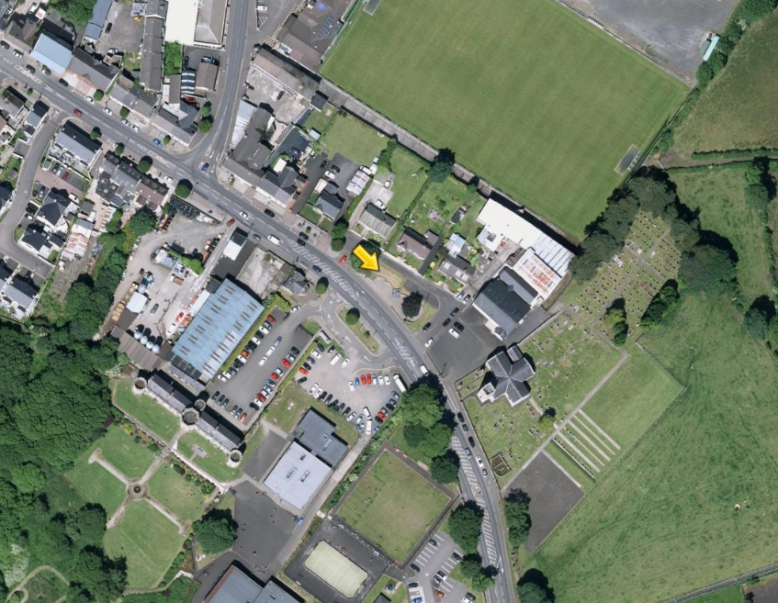
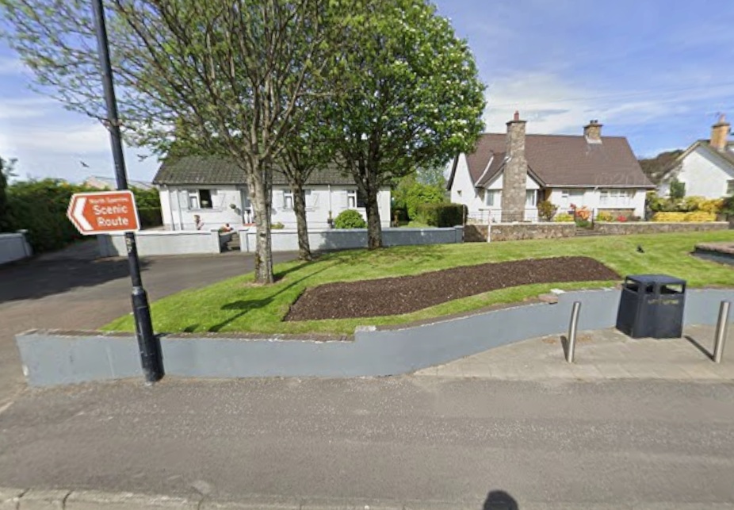

- Site A25 – Ballyclose Street Roundabout, Limavady

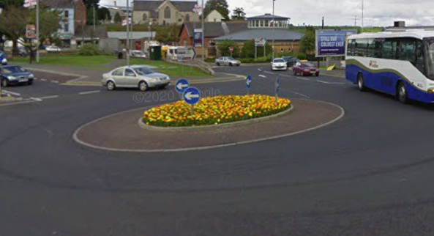

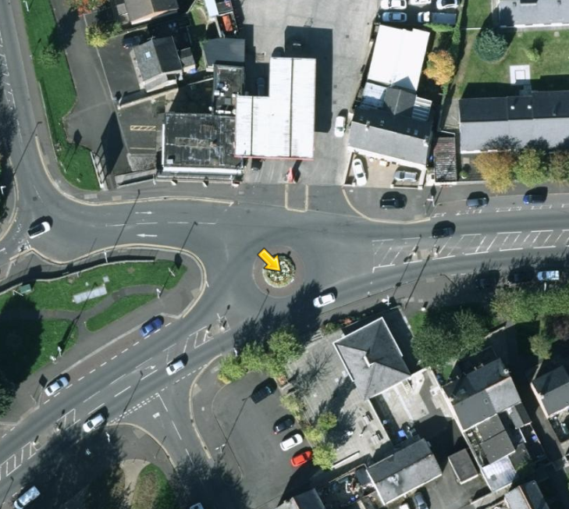
- Site A26 – Flowerbed at Bells Hill, Limavady

