**Causeway Coast and Glens Borough Council**

**Terms and Conditions and Guidance Notes October 2025**

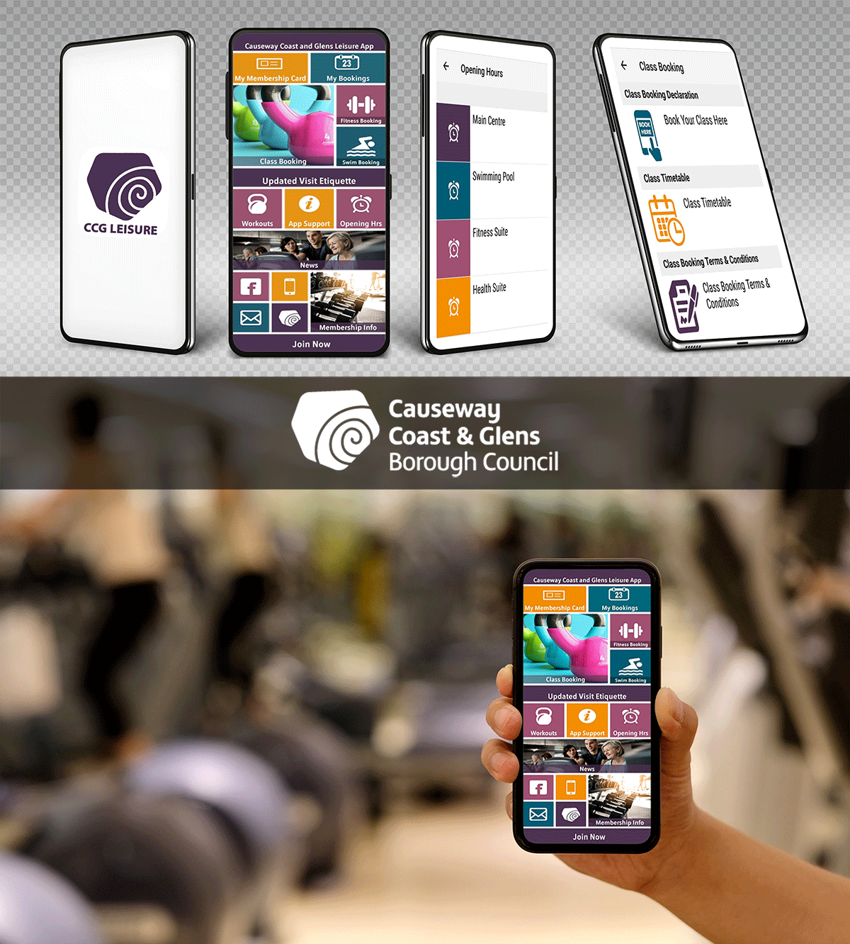

Dear Member

Thank you for becoming a Member of Causeway Coast and Glens Borough Council Leisure Centres. The following information is designed to clarify all the guidelines and rules around using and paying for these facilities, within your membership.

**Online & Mobile App Membership Registration**



Download this link

<https://causewaycoastandglens.legendonlineservices.co.uk/enterprise/account/Registration>

|  |  |
| --- | --- |
| Step 1. | Get your membership number from your leisure centre Reception & confirm your date of birth, postcode & mobile number |
| Step 2. | Register with the link below and the system will send you an email to confirm registration. – Please check spam emails. |
| Step 3. | Once registration is confirmed via email – log in again via the link. |
| Step 4. | Click-on connect to my membership and add in your membership number, postcode, mobile & date of birth. |

# App bookings

Download the new CCG Leisure app in your google play store or i-phone. <https://play.google.com/store/apps/details?id=com.innovatise.ccgleisure> App store <https://apps.apple.com/gb/app/ccg-leisure/id1470207136>Google play

 Apple QR code – please scan

If you have free classes in your membership then you can book a class in the Leisure Centre where your membership is linked.

Our app has the latest information with regards to bookings, opening times, membership questions and Covid-19 updates.

# Online Class bookings

You can also book a class & pay for a class in another facility on our online system

Log in -<https://causewaycoastandglens.legendonlineservices.co.uk/enterprise/Account/Login>

* Login by using the email and password you used to register online.
* Select – Make a booking
* Select the club you wish to go to, select the activity and view timetable.
* Add the class to the basket and then select payment (if required).
* To cancel a class – go to bookings on your account and select cancel.

# App booking Terms & Conditions –

* Booking for classes opens at 7am, 7 days ahead. If you have classes in your membership, cancellation up to 2hrs minutes before the class starts.
* If you can’t make it – please cancel
* If you don’t cancel we send a booking strike. 3 booking strikes within 30 days then you get a booking ban and can’t book on the app for 30 days.
* Always check in at reception before the class starts – allow 5 minutes for this and always be there early.
* If you don’t check in – you will get a booking strike.
* If you arrive late you may not be able to participate in the class for health and safety reasons.

# Class waiting list

* If classes are full, you are placed on a waiting list of up to 5 people.
* If a space becomes available the system will contact ALL on waiting list via email.
* If you are contacted off the waiting list, you must log into the app and book that space that has become available.
* The first person back, will be added to the class. If you have been contacted and there is no space to book, this means you have missed the space this time.
* If you have been contacted and don’t intend to take the space then please cancel the class to allow someone else to be contacted.
* Other members won’t be contacted until you remove yourself from the class waiting list.

# Suspension of Membership

* Membership may, under specific circumstances (see below), be frozen or suspended for a period of 1-6 months subject to prior receipt of the request in writing / email and approval by CC&G. You can freeze up to twice a year.

* Approval is only granted for specific reasons and evidence to support the request may be required.

* Depending on the circumstances there will be a £5 fee for each month of suspension.

* If paying by direct debit – the freeze request will be in line with this payment – for example if the direct debit is lifted on the first of the month and you request the freeze

on the 20th of the month, this is not possible. The freeze request month run from the 1st to the end of that month.

* If the payment is by Cash for 6 to 12 months – the freeze is possible at any time.

* All freeze requests must give at least 7 days’ notice prior to a direct debit collection.

* Member cannot use the centres during the month which is frozen, except where they pay an appropriate pay and go charge for each activity at reception.

* Freeze requests are not permissible after the time has gone. For example, the member has not used the facilities for 2 months but applies for a freeze to be back dated.

* All freeze requests must state the start date and finish date – CC&G cannot freeze a member indefinitely.

* When providing the finish date of the freeze request – the membership will start automatically the next day. To extend a freeze, the notice must be re- applied for via email.

* **When emailing a freeze request – please state FREEZE REQUEST on the Subject Field. Your name, membership number, date from & to. The freeze is not automatically started once email is sent, you must wait for confirmation from the Membership team.**

Please email leisure.membership@causewaycoastandglens.gov.uk

Terms and conditions for freeze request –

* Injury/illness – a doctor’s letter may be requested.
* Pregnancy
* Out of the country for longer than one month.

# Cancellation of Membership

* Membership’s cannot be cancelled within 7 days of the payment collection date.
* Notice must be given to the Membership Team by email to providing your name, address and membership number.
* The membership is not cancelled until confirmation email is sent.
* If the member has not received confirmation within 1-2 working days, then please contact the Membership Team.
* It is the member’s responsibility to cancel the direct debit instruction at the bank.
* You can continue to use your Membership for a further 30 days from your last cancelled payment.
* Monthly direct debits will roll on until the member has cancelled – they do not finish after one year term.

To cancel –

* Send a brief email to the Membership Team leisure.membership@causewaycoastandglens.gov.uk

Upfront Cash memberships for 6 & 12 months cannot be cancelled or transferred.

|  |
| --- |
| **THE DIRECT DEBIT GUARANTEE –** This Guarantee should be retained by the Payer |
| * This Guarantee is offered by all banks and building societies that accept instructions to pay Direct Debits * If there are any changes to the amount, date or frequency of your Direct Debit Causeway Coast and Glens Borough Council will notify you 10 working days in advance of your account being debited or as otherwise agreed. If you request Causeway Coast and Glens Borough Council to collect a payment, confirmation of the amount and date will be given to you at the time of the request * If an error is made in the payment of your Direct Debit, by Causeway Coast and Glens Borough Council or your bank or building society, you are entitled to a full and immediate refund of the amount paid from your bank or building society.   - If you receive a refund you are not entitled to, you must pay it back when Causeway Coast and Glens Borough Council asks you to.  • You can cancel a Direct Debit at any time by simply contacting your bank or building society. Written confirmation may be required. Please also notify us. |

# Arrears Process

* Members whose direct debit payment is returned unpaid will be automatically reapplied for on the next direct debit date.

* For example, CC&G lift direct debits on the 1st & 15th of every month. If the payment has failed on the 1st then an automatic reapplication will happen on the 15th.

* If this payment is successful then the next date of collection will be back to the 1st.

* If the payment is unsuccessful, the membership will be terminated/cancelled.

* Any outstanding amount owed must be paid and failure to pay may result in legal action.

* Arrears payments may also be paid at the Centre.

* Access to facilities will be frozen until payment is made.

# Membership upgrade & Downgrades

If a member wishes to change their Membership Package i.e. Upgrade or downgrade their

membership package or revert from direct debit to a pay in full 12 month Membership, this must be completed at the Centre.

* If a member is upgrading, they may need to pay the appropriate pro-rata charge by cash or card to activate an upgrade immediately. Members can only downgrade 5 days before your Direct Debit collection date to work alongside the Direct Debit payment or if it’s a cash membership, they can downgrade at the end of the year.

* If a member is on an old membership price that is legacy or a price for life, they may upgrade to any membership that is sold at the centre but they cannot downgrade to the old legacy price.

# Junior membership upgrade

Junior membership runs out when a junior turns 18yrs old, you will receive a notification email. If you do not respond after 30 days your membership will be terminated and changed to a Casual Pay as You Go.

# Fitness Suite Inductions

Everyone new to our Fitness suites must have an Induction so they can use the equipment safely and effectively.

* Inductions should be available to new members within a week of joining. Inductions have to be carried out in each centre, however, after 1st induction, the rest may be fast-tracked.

* Our Fitness staff are always available to help with equipment and workout programmes.

* Content and format may differ at each Centre.

* Medical Fitness Questionnaire from called a ParQ is filled in prior to induction.

* Changes to your health – during the term of your membership, should your health change, you must inform a gym staff member as your programme may need to be altered and the medical form will need updated.

# Photographs and Non transferability of Membership cards

It is the condition of CC&G membership that Centre Staff must take a Photograph of the Customer to be stored in the Centre’s computer system along with the other membership details.

* Membership cards or the Membership its self are non-transferable.
* Where the non-transferability is abused by a Member Causeway coast and Glens Staff have the right to cancel the Membership at any time.
* Damaged, lost or stolen cards must be reported to reception. A replacement card fee may be charged.

*Causeway Coast and Glen’s Borough Council will treat and stored all information given in accordance with the Data protection regulations. Causeway Coast and Glen’s Data protection policy can be view on the Causeway Coast and Glen’s website*

<https://causewaycoastandglens.gov.uk/council/publications-policies/data-protection-policy-revised-2018>

# Access to activities

All new CC&G members will be given a Causeway Coast and Glens Gym access card on becoming a member.

* Members will be expected to produce their membership card at Reception when requested by the Reception staff as proof of Membership and Membership package type before access to the facilities is permitted.
* Some sites will also require the Customer to swipe the card at the Gym/Health suite entrance door to gain access.

# Opening Times

All Centres will be closed on Easter Sunday, Christmas Day, Boxing Day and New Year’s Day.

We may offer a reduced service on Bank Holidays, and over the Christmas and Easter periods.

CC&G’s reserves the right to close centres or facilities for cleaning, maintenance and refurbishment work. Prior notice will be given for such work unless circumstances outside of CC&G control create the necessity for immediate works.

If a facility is not available due to large scale maintenance or refurbishment, CC&G’s Members have the option of maintaining their membership and using another CC&G’s facility or suspending their membership for the duration of the closure.

**Closures of Centre(s)**

Centres may be closed or operate on a reduced hour’s basis on certain days for example - government events such as elections. Such closures and reduced hours operations will always be planned and published well in advance. It is deemed that all Members agree and accept, in advance, that such closures and reduced hours operations are an integral part of the package purchased.