Causeway Coast and Glens PCSP
Annual Report 2023-24

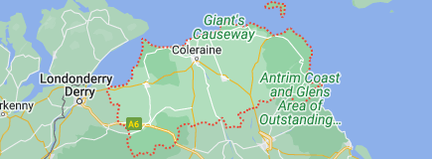

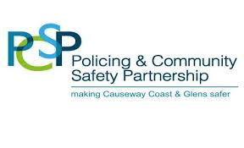
Contents Page

Page Number

4 Foreword

6 Profile of Causeway Coast & Glens

8 Causeway Coast & Glens PCSP

11 Causeway Coast & Glens PCSP Membership

12 Strategic Objective 1: To ensure effective delivery in response
to local need, and improve the visibility and recognition of the
work of the PCSP through effective consultation, communication
and engagement

20 Strategic Objective 2: To improve community safety by prioritising
and addressing local community safety issues, tackling crime and
anti-social behaviour

41 Strategic Objective 3: To support confidence in policing, including
through collaborative problem solving with communities

50 PCSP and Community Planning

54 FYTD / PFYTD Comparison – Causeway Coast and Glens

55 PCSP Financial Statement

56 Contact us

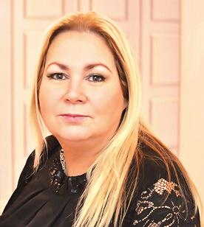

Councillor Ivor Wallace Patricia McQuillan
Chair Vice-Chair

We are pleased to publish the Annual Report for the period 2023-2024, which summarises the progress of the Partnership against the local outcomes it has agreed and the strategic objectives set by the Department of Justice and Northern Ireland Policing Board.

This report seeks to evidence the work of PCSP Members and staff that continues to focus on achieving a safer community; reducing levels of crime, anti-social behaviour and fear of crime; and improved confidence in policing.

With reduced resources, we have taken significant steps to improve public engagement. We will continue to work with local communities to develop and deliver innovative solutions that meet local needs despite significant constraints including in police staffing levels. A full list of projects are included in this Annual Report which include three significant achievements:

- Disability Project- Development of Hate Crime lesson Plan in partnership with Disability Action, Causeway Neurodiversity, Mencap, Education Authority, Hate Crime Advocacy Service and PSNI. CC&G was the first PCSP to complete research in this (244 engaged) and engage with disabled residents with regard to PCSP work to assist in community safety issues and challenges faced. Winner of PCSP category in PSNI Problem Solving Awards 2024.
- Causeway Coast and Glens PCSP has launched a ‘cyber safety’ resource - the only one of its kind in Northern Ireland. The PCSP partnered with the NSPCC, the Northern and Western Health Trusts and the Education Authority to develop the toolkit, which aims to support young people with topics such as: • suicide, mental health, and self-esteem • online bullying • gaming and gambling • sharing and receiving inappropriate images. The resource is intended to be used by a range of organisations, such as in schools or youth groups. It provides animations, lesson plans and other supporting resources designed to support young people in need. The free resource can be viewed at https://view. pagetiger.com/online-safety-and-mental-health. This initiative was finalist in PSNI Problem Solving Awards 2024.
- Since 2018: Speed Identification Devices have been deployed 171 times = 4851 days = 4 million+ drivers

The PCSP has also strategically-themed working groups with both Independent and Elected Chairs focusing on:

- PCSP Projects
- Grant Funding
- Confidence in Policing

These Working Groups focused on emerging issues and developing solutions with our strategic partners that were submitted to the PCSP Board for approval and implementation.

The Action Plan for next year will continue to develop this work along with other new initiatives and be reflected in the PSNI Local Policing Plan. We will reflect applicable aspects of the Programme for Government and local Community Planning in those plans.

We are encouraged by the growing level of public interest in the work of the PCSP. We would wish to acknowledge and thank those people who took part in projects or contacted us with concerns. We encourage you to continue to engage with us over the next twelve months through your local Independent and elected representatives, and our staff.

We will continue to address the multiple challenges to community safety that exist within the Borough but need your input and support to do so at a time when resources are being reduced. We appeal to you to report community safety issues as they happen and help us to address them, making your Borough a safer place to live and work.

Chair Vice-Chair
Councillor Ivor Wallace Patricia McQuillan

Profile of Causeway Coast and Glens

Causeway Coast and Glens stretches from Lough Foyle in the west to the Glens of Antrim in the east covering an area of 1,968 square kilometres. This makes Causeway Coast and Glens one of the largest Councils in Northern Ireland in terms of land mass.
Whilst largely a rural borough, there are a number of established settlements within the including Coleraine, Ballymoney and Limavady.

Causeway Coast and Glens population in 2019 was estimated at 144,838 (7.6% of Northern Ireland’s population). Between 2001 and 2019, the population of the Borough increased by 13,464 persons, a growth rate of 10.2% which is below the NI average of 12.1%.

The table below provides a breakdown of the population by age, with 19.6% children, 61.9% representing the majority of the working age population (16-64) and 18.4% aged 65 years and over.

Age Band | CCGBC | % | NI | %
Children (0-15 years) | 28,411 | 19.6% | 395,925 | 20.9%
Young Working Age (16-39 years) | 41,778 | 28.8% | 578,542 | 30.6%
Older Working Age (40-64 years) | 47,995 | 33.1% | 604,476 | 31.9%
Older (65 years+) | 26,654 | 18.4% | 314,724 | 16.6%
Source: NISRA Mid-Year Estimates

There is a larger proportion of people aged 65 and over living in the Borough (18.4%) compared to the Northern Ireland average of (16.6%). This indicates a sharply ageing demographic profile in this area.

Life expectancy at birth for both females and males within the Borough are above the NI average at 83 and 79 respectively.

On average the area ranks above the NI average in all indicators, ranking second highest in life satisfaction of all 11 Local Government Districts (LGDs).

In 2018, there was a total of 2,538,877 visits to visitor attractions in the Causeway Coast and Glens area. The most popular visitor attractions where: Giant’s Causeway World Heritage Site (1,039,243) followed by Carrick-a-Rede Rope Bridge (491,947) and Roe Valley Country Park (310,000).

There are Seven District Electoral areas (DEAs) within the Causeway Coast and Glens Borough Council area and 40 wards as outlined in the maps below.

Map of the 40 Wards (and DEAs) in Causeway Coast and Glens

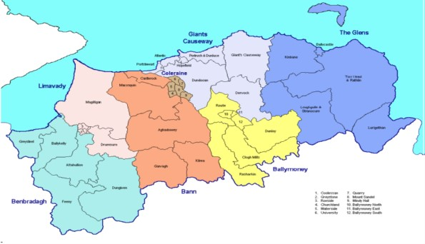

  - The proportion of young people living in the area is declining but still significant - need to look after young people’s well-being;
  - The area’s many natural attractions such as coastlines, beaches, hills, mountains, islands, and historic monuments - offer significant opportunities for engagement and diversionary activities, particularly for young people;
  - There are a number of large events hosted in the area such as the North West 200 which attracts over 100,000 spectators annually to the Council area and the annual Super Cup NI (formally NI Milk Cup). This illustrates the importance of a safe and welcoming place;
  - There is a growing number of older people residing in the Council area - focus on isolation and fear of crime;
  - The Council area is represented by both main traditions in Northern Ireland but also has a sizeable ethnic minority population as well;
  - The statistics demonstrate that there are still many areas where poverty and income deprivation is the norm - this can be contributory factor to some crime related incidents;
  - Educational attainment at GCSE with English and Mathematics is lower than the NI average -this can be contributory factor to some crime related incidents;
  - Unemployment, long term unemployment, economic inactivity and the number of people with no qualifications is an issue across the Causeway Coast and Glens Borough Council area with three Neighbourhood Renewal areas located within it in Coleraine and Limavady - another contributory factor to some crime related incidents;

Causeway Coast and Glens Policing and Community Safety Partnership

Causeway Coast and Glens PCSP, established under the Justice Act (Northern Ireland) 2011, has the overall purpose of helping to make communities safer and to ensure that the voices of local people are heard on policing and community safety issues. The aim is to empower communities to help develop solutions that will help tackle crime, fear of crime and anti-social behaviour.

Strategic objectives for Causeway Coast and Glens Policing and Community Safety Partnerships are as follows:

Strategic Priority 1 – To ensure effective delivery in response to local need, and improve the visibility and recognition of the work of the PCSP through effective consultation, communication and engagement
through:
- carrying out meaningful engagement in the district with the local community, relevant statutory partners / agencies, businesses and the community & voluntary sector in the development and implementation of PCSP Action Plans;
- ensuring ongoing two-way engagement in the district with the local community, relevant statutory partners / agencies, businesses and the community & voluntary sector to provide a problem-solving forum to identify effective solutions to local issues, ensuring sufficient flexibility to address issues as they emerge, and seeking relevant expertise from the designated organisations as appropriate;
- using a range of platforms, including multi-media, to communicate and promote the work of the PCSP; and
- increasing awareness of the work of the PCSP.

Strategic Priority 2 - To improve community safety by prioritising and addressing local community safety issues, tackling crime and anti-social behaviour
through
- utilising the partnership created by the statutory, elected and independent/ community membership of the PCSP to initiate and lead work to improve community safety and tackle ASB locally;
- working in partnership to develop outcome and locality focused interventions to address the most pressing crime types and behaviours impacting local community safety, as evidenced by local need, with appropriate targets and indicators so that impacts can be measured;
- drawing on best practice, promote early intervention and collaborating effectively to improve PCSP-supported projects and programmes that address the underlying causes of ASB, crime and the fear of crime in the community, including, where appropriate, a focus on changing behaviours;
- enhancing safety and feelings of safety, in particular for those who might be more vulnerable;
- engaging with partners in the district, to horizon scan in order to respond to and re-direct resources to respond to emerging local community safety issues;
- having cognisance of the Community Safety Framework in developing local plans, and providing a feedback loop to the Community Safety Board on local issues in order to inform community safety policy development – and vice versa; and
- providing comprehensive community input into decision making processes about tackling actual and perceived anti-social behaviour and giving feedback to the community on the effectiveness of interventions on meeting outcomes.

Strategic Priority 3 – To support confidence in policing, including through
collaborative problem solving with communities
through
- ensuring local accountability through the Policing Committee’s role in monitoring police performance;
- identifying priorities from the PCSP Plan for consideration in the development of the local Policing Plan which are consistent with the Northern Ireland Policing Plan;
- providing views to the District Commander through the Policing Committee and supporting the PSNI to engage with the community to identify and address local problems;
- delivering initiatives that link to identified local problems that impact confidence in policing;
- carrying out meaningful local events aimed at increasing PSNI engagement with local communities to build and strengthen public confidence in policing;
- delivering PCSP initiatives in the hardest to reach communities;
- providing a platform for the PCSP and PSNI to engage with young people, including on the themes of upholding the rule of law, and of ways of increasing confidence in policing; and
- building community confidence in the rule of law by helping mitigate the harm caused to people and communities by paramilitarism, criminality and organised crime consistent with wider Programme for Government objectives and through use of co-design principles, where appropriate.

  - The Strategic Priorities may however be reviewed at any time by Joint Committee to ensure that they are fit for purpose in relation to the effectiveness of PCSPs.

  - In addressing the three Strategic Priorities, PCSPs are required to take account of a number of developments, including:
- The Community Safety Framework
- The Northern Ireland Policing Plan 2020-2025 and Annual Performance Plan 2020/2021
(c) Criminal Justice Inspection NI report “Working together for Safer Communities: A review of Policing and Community Safety Partnerships in Northern Ireland”.
(d) Public Satisfaction with PCSPs
(e) Together: Building a United Community
(f) Tackling Paramilitary Activity, Criminality, and Organised Crime Programme
(g) Community Planning
(h) Participatory Budgeting

Causeway Coast & Glens PCSP’s Policing Committee has debated and agreed the local policing plan priorities with the Area Commander throughout the year.

Partnership objectives were achieved through joint working with the public, voluntary, private and community sectors at a local level. A wide range of organisations have a role in developing programmes and actions that will systematically tackle the underlying causes of crime and anti-social behaviour, rather than simply dealing with the problems which present.

Causeway Coast and Glens Policing and Community Safety Partnership

Causeway Coast and Glens Policing and Community Safety Partnership consists of 10 elected members, 9 independent members appointed by Northern Ireland Policing Board (NIPB) and statutory organisations appointed via an Assembly designation process, as follows:
- the Police Service of Northern Ireland
- the Northern Ireland Housing Executive
- the Probation Board for Northern Ireland
- the Youth Justice Agency of Northern Ireland
- Health and Social Care Trusts
- Education Authority of Northern Ireland; and
- the Northern Ireland Fire and Rescue Service

Outlined below is the structure of Causeway Coast and Glens PCSP:
Joint Committee
Council

uncil
Department of Justice (DOJ)
PCSP
Operational /Delivery Partnership sub-groups
Policing Board
Policing Committee

Causeway Coast and Glens PCSP has a Policing Committee consisting of the political and independent members who are tasked with functions in respect of monitoring police performance and inputting into the local policing plan.

Causeway Coast and Glens PCSP Membership
Independent members of Causeway Coast and Glens PCSP
Ms Leanne Abernethy
Mr Steven Chambers
Mr Lee Kane
Mr Neale Jagoe
Mr Derek McDonald
Mr Sam McGregor
Mrs Patricia McQuillan
Mrs Adele Tomb
Mrs Caroline White

Political Members of Causeway Coast and Glens PCSP

Councillor | Philip | Anderson | DUP
Councillor | Ciaran | Archibald | SF
Councillor | Steven | Callaghan | DUP
Councillor | Brenda | Chivers | SF
Councillor | Mark | Fielding | DUP
Alderman | Lee | Kane | Alliance
Councillor | Oliver | McMullan | SF
Councillor | Leanne | Peacock | SF
Councillor | Ivor | Wallace | DUP
Councillor | Darryl | Wilson | UUP

STATUTORY REPRESENTATIVES
Organisation | Representative
Police Service of Northern Ireland | Supt Mark Roberts
Northern Ireland Fire and Rescue Service | Alan Murdoch
Northern Ireland Housing Executive | Mark Alexander
Northern Health and Social Care Trust | Heather McCarroll
Western Health and Social Care Trust | Mandy Fitzgerald
Education Authority Northern Ireland | Deirdre Bradley
Probation Board for Northern Ireland | Nuala Quinn
Youth Justice Agency of Northern Ireland | Erin Higgins

If you would like further information on PCSP members please use the contact details at the back of this report.

Strategic Objective 1- to successfully deliver the functions of the Policing and Community Safety Partnership for the area - sets out targets for member engagement, community/media engagement and Support Hub.

PCSP Meetings - Members’ Attendance

April 2023 to March 2024 | Board | CIP | P WG | Grant | Other | Left
Ms Leanne Abernethy | 6 | 1 |  | 9 | 1
Cllr Philip Anderson | 8 | 1 | 1 | 8 | 6
Cllr Ciaran Archibald | 6 | 1 | 1 | 4 | 2
Cllr Steven Callaghan | 4 |  |  | 1 | 5
Mr Steven Chambers | 3 |  |  | 2 |  | Oct 23
Cllr Brenda Chivers | 6 | 1 |  |  | 5
Cllr Mark Fielding | 3 |  |  | 7
Cllr Sandra Hunter | 1 |  |  |  |  | June 23
Mr Neale Jagoe | 3
Cllr Lee Kane | 6 |  |  | 3 | 4
Mr Derek McDonald | 1
Mr Sam McGregor | 6 | 1 | 1 |  | 1
Cllr Oliver McMullan | 5 |  |  |  | 4
Mrs Particia McQuillan | 8 | 1 | 1 |  | 21
Cllr Leanne Peacock | 3
Mrs Adele Tomb | 1 |  |  |  |  | June 23
Cllr Ivor Wallace | 5 |  |  | 6 | 10
Mrs Carolyn White | 7 | 1 | 1 | 8 | 2
Cllr Darryl Wilson | 5 |  |  |  | 2

PCSP Meetings – Statutory Attendance

April 2023 to March 2024 | Attendance
EANI | 5
NIHE | 8
NH&SCT | 1
NIF&RS | 7
PBNI | 0
PSNI | 8
WH&SCT | 1
YJA | 4

Strategic Objective 2 - to improve community safety by tackling crime and anti-social behavior – this objective has 6 themes with a number of projects under each theme:

Theme 1: Anti-social Behaviour

Graffiti Removal Scheme
This scheme helps maintain a graffiti-free environment throughout Causeway Coast and Glens by enabling prompt action to remove graffiti.

On receipt of reports from PCSP members, police, elected representatives, council staff or residents, a check is carried out to determine ownership of the property or site and asses if it is the responsibility of a statutory partner or falls under the remit of the PCSP Scheme criteria. Once established, removal is actioned or a referral made to the appropriate partner.

The scheme saw an appointed contractor respond to over 85% incidents of graffiti across the council area within a 48hr period.

How much did we do?
62 of referrals received (14 referred to NIHE/CCG)
48 of referrals responded to
680 of square metres of offensive graffiti removed

How well did we do it?
100% referrals removed inside 48hrs. Due to illness one case took 72hrs to be removed.

98% of local communities satisfied with graffiti.

Is anyone better off?
4 repeat graffiti locations. All locals spoken to when contractor was out removing graffiti where happy to see it being removed.

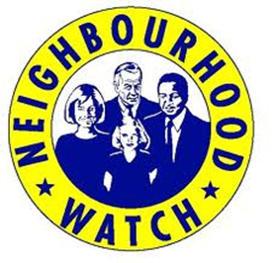
Neighbourhood Watch

Neighbourhood Watch, a partnership between local communities, the Police and PCSPs, aims to help people protect themselves and their property and reduce the fear of crime. Schemes create effective communication between residents and the police, with local coordinator’s acting as a primary point of contact.

Regular contact was made with Coordinator to ensure that they were up to date with support and crime trends, scams, information on support such as crimestoppers. All Neighbourhood watch coordinators were invited to take part in crime prevention training carried out by the Police Crime Prevention Academy.

Two editions of the Neighbourhood watch newsletters were circulated throughout the year.

How much did we do?
40 schemes in operation 47 coordinators. One Neighbourhood watch newsletter designed and circulated.

How well did we do it?
60 % of respondents who feel NHW is working well
Is anyone better off?
70% of respondents who have adopted crime prevention advice
60% participants more likely to report crime
30% rated confidence in police as high
40% rated confidence in police neither high or low
10% rated confidence in police low and 10% rated confidence in police very low

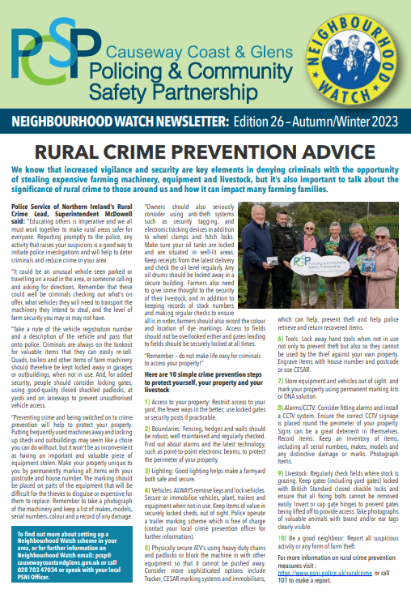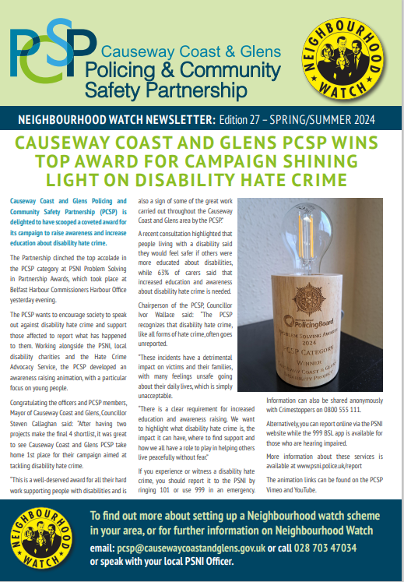

2 Fast 2 Soon – PCSP joined forces with the PSNI and NIF&RS to drive home the importance of road safety at events right across the Causeway Coast and Glens Borough council area.

A number of road traffic collision demonstrations were played out.
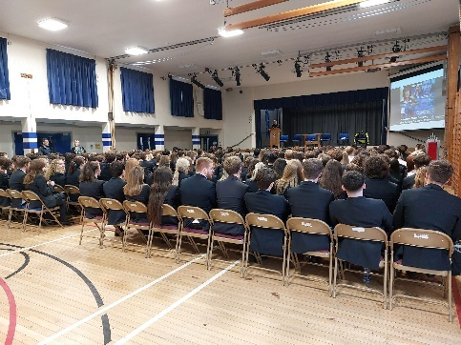
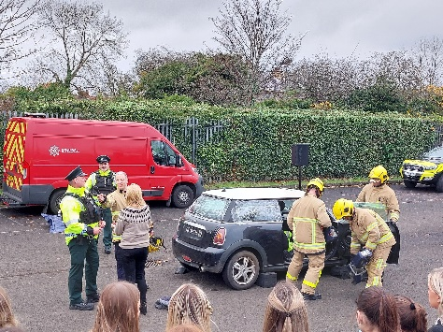
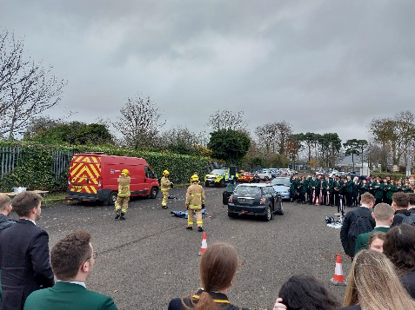

The events also featured the PCSP’s car crash simulator and the primary objective was to encourage better driving and a safer approach to getting behind the wheel.

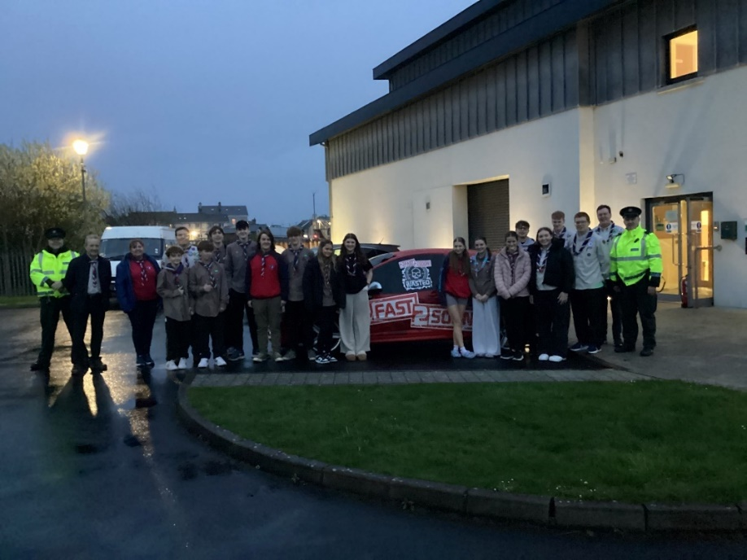
Accident demonstrations are a powerful way to share the road safety message where PSNI and the NIFRS are key partners. There was 100% positive feedback from the different events.
How much did we do? 8 presentations/demonstrations 2200 participants engaged across CCG visited
How well did we do it? 100% teachers or youth organisers satisfied with the event 90% participants satisfied with the experience
Is anyone better off? 30% participants reporting learning new information
40% participants reporting changed attitudes to RTCs and driving behaviour
2200 of participants who have a better understanding of road safety

Speed Indicator Devices (SIDS)

Since the inception of PCSPs in 2011, every public meeting has had a significant focus on speeding and dangerous driving throughout the Borough. Based on this need CC&G PCSP researched and purchased 4 mobile SID units for deployment throughout the Borough in 2017, with further units purchase since then, there are now 8 trailer double mounted units, with further developments 2023/24. SIDs are primarily mounted upon sign poles which created significant challenges for Roads Service resulting in CC&G PCSP having to develop this innovative solution.

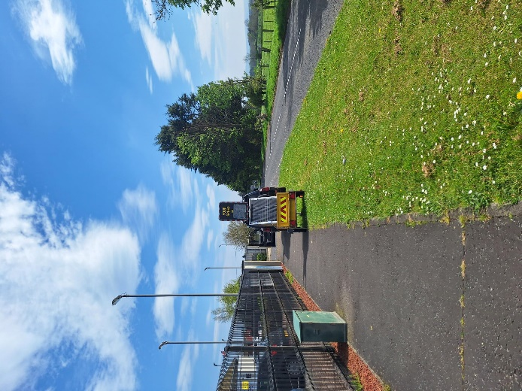
By mounting two SID units on trailer’s they became mobile which allows maximum flexibility in responding to need and complaints of speeding and captures data from both sides of the road at the same time.

These mobile units are available on request from anyone within the local community and are placed for a period of approximately 2-3 weeks, allowing a firm baseline of data on which to be built.

The trailers act as an awareness raising source and promote the work of the local PCSP.

These devices notify drivers of their speed whilst recording the data but not punishing any offences, educating road users to slow down. The data can also be used to challenge Road Services on the need for road calming measures.

It also allows intelligence led Police speed enforcement operations at recorded evidence based peak times, which in turn will show the community that the Police are doing their jobs effectively and increase confidence in Policing.

Therefore, utilising the PSNI limited resources more efficiently and increasing road safety.

Causeway Coast and Glens PCSP, being the first PCSP at be funded for SID units, have assisted other PCSP’s to set up their SID projects.

Since conception in 2018 the SID project has achieved the below results.
 | 2018/19 | 2019/20 | 2020/21 | 2021/22 | 2022/23 | 2023/24 | Totals
Locations | 9 | 27 | 25 | 47 | 53 | 10* | 171
Days deployed | 91 | 358 | 415 | 1617 | 1689 | 777 | 4947
Drivers Educated on Speed | 95,016 | 401,659 | 300,278 | 1,519,162 | 1,272,128 | 608,973 | 4,102,200
Deployers | PSNI | PSNI | PSNI | PCSP staff | PCSP staff | PCSP staff
*Only 10 deployments due to trailers being modified to carry two Sid units and associated equipment.
How much did we do?
12 of (double) deployments
777 days of deployment
57 of referrals from community (66 on waiting list)
How well did we do it?
12 of data reports produced for communities
100% Community satisfaction
100% of reports provided to PSNI to inform priorities
Is anyone better off?
67% of drivers reducing speed when SID is in place
608,973 drivers made aware of their speed

New Driver Safety Ambassadors


1750 learning resources were distributed to all post primary schools within the council area. 100% of schools were satisfied with service.

1250 Senior citizen resources distributed throughout the Causeway Coast and Glens Borough council.

14 Secondary schools visited, and workshops completed with all driving age students.

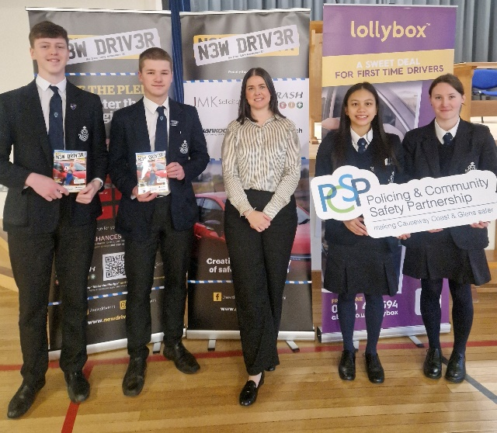
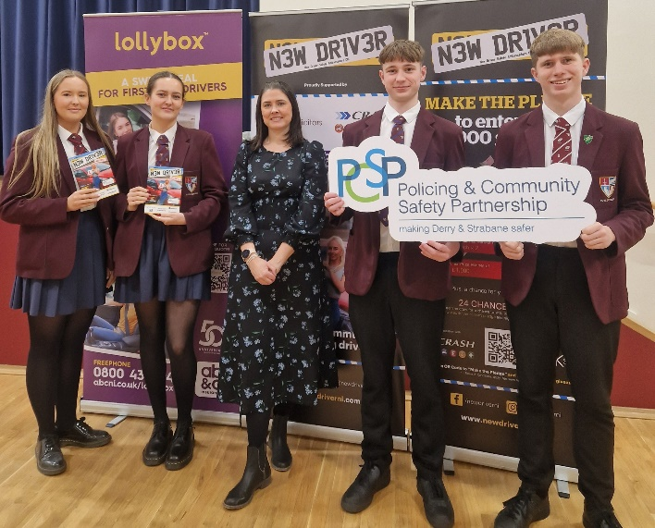


Senior Driver
Improving road safety throughout the Causeway Coast and Glens council area. New Driver NI in partnership with CC&G PCSP developed a resource booklet for the Senior Driver.

Theme 2: Drug and Alcohol Related Crime

Education Programme :- Last Orders

The aim of the school’s project was to make children aware of the physical, mental and emotional consequences that risk taking behaviours may possess.

Developed by a team of doctors, NSPCC professionals and teachers, “Last Orders” is a professional and specialist theatre company production telling the story of three teenagers embarking on an alcohol fuelled night out and exploring the disastrous consequences. Based on true events, the play is written in a hard-hitting yet humorous style.

The educational play highlighting the dangers of alcohol and anti-social behaviour and online safety was hosted in post primary schools across the Causeway Coast and Glens Council area.

The 50 minute play was followed up by an interactive classroom-based workshop which highlighted the impact of alcohol on risk taking behaviours including online behaviours. In 2023 on request of school Principals’ the workshop included the dangers of vaping including vape spiking. Workshops also including additional issues such as: organised fights and highlighted One Punch Can Kill messages.

Performances of ‘Last Orders’, organised by Causeway Coast and Glens Policing and Community Safety Partnership and delivered by Solomon Theatre Company, were delivered in the school setting in October 2022 and November 2022.
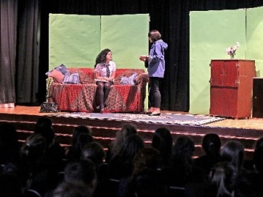

How much did we do?
1411 pupils participated in project
100% offered to all post primary schools
How well did we do it?
15 (83%) of post primary schools participating
160 (177 responded to evaluation) 94.4% of young audience satisfied with quality of event.
Is anyone better off?
69.64% audience giving increased thought to the consequences of risk taking behaviour.
75% audience feeling better able to assess, avoid and access support for risk taking behaviours.

Theme 3: Domestic, Sexual Abuse & Coercive Behaviour

Domestic Abuse
Domestic abuse is a major problem with PSNI receiving calls every 17 minutes in Northern Ireland. It takes a victim to generally be abused 34 times before reaching out for help. By providing equipment to individuals at high risk to protect, increase confidence, deter attacked and gather evidence to support prosecution they are made to feel safe in their own homes.
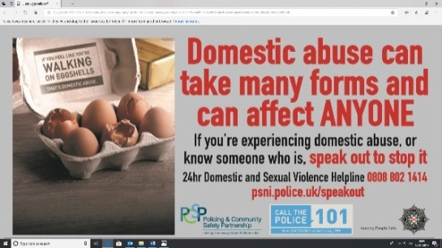
The police role is about prevention, protection and prosecution – to prevent further violence, to protect the victim, children and other vulnerable people and to facilitate the prosecution of offenders. They work closely with statutory and voluntary partners, to ensure the victims get the help they deserve, to highlight the issue of domestic abuse and to explore ways in which we can keep communities safer.

There are dedicated domestic abuse officers across Northern Ireland to ensure that all domestic abuse crimes are investigated, whilst providing support and information to victims about police procedures and legal proceedings.

Domestic abuse cannot be dealt with solely by the police and it is important that the partnership work continues in order to highlight the issue of domestic abuse and explore ways in which we can all make our communities safer. The PCSP also works closely with Women’s Aid in relation to the support offered to victims and early intervention in schools.

Domestic abuse and stalking support equipment

Domestic abuse and stalking support equipment were purchased and issued to individuals at high risk via PSNI to protect, increase confidence, deter attack and gather evidence to support prosecution. These items included: CCTV, Door bracers, personal panic alarms etc

“The equipment is issued to Domestic abuse victims of high risk of death/serious nature and therefore the Victims all report 100% for better off when equipment issued. The PSNI hold stock of this PCSP equipment and can issue these immediately where appropriate.”

Domestic Abuse Extra Support Hours
Over a thousand crimes are reported in relation to domestic violence in a year in CC&G. These affect entire families. People who return to violent situations face risk of further abuse. There is evidence that children familiar with abuse are prone to accepting abusive behaviour. Supporting victims to change their situation is vitally important.
Causeway Coast and Glens PSNI reports of domestic abuse incidents and crimes have increased steadily.
CC&G PCSP want to ensure that vulnerable persons experiencing Domestic Abuse can access the support they require without having to wait a disproportionate length of time due to high volumes of people accessing services. That victims can have access to equipment to protect, increase confidence, deter attacks and gather evidence to support prosecution where appropriate. Provide education on healthy relationships as an early intervention
Causeway & Mid Ulster Women’s Aid receive funding for extra support hours for victims of domestic abuse within Causeway Coast and Glens Borough area.

How much did we do?
71 of victims WA supported (14 full support)
1040 of hours of support
How well did we do it?
71 of victims supported to access additional support services
Is anyone better off?
100% who learned about access to other supports
Teenager Healthy relationships programme
PCSP members identified a “gap” in services for a Teenagers Healthy relationships programme. Causeway & Mid Ulster (also in partnership with Foyle Women’s Aid) were successful in the tender process and have delivered education sessions throughout Causeway Coast and Glens Borough Council area schools.

The following Post primary school Teenagers Healthy Relationships sessions were provided:
Session 1  Relationships | Introduction; confidentiality; disclosures.  What a relationship is, types of relationships, our needs and who meets our needs, choice, and behaviour in relation to self and others, links between thinking, feelings, historical social norms, cultural norms, society values, understanding myths and stereotypes
Session 2  Healthy/Unhealthy Relationships  Coercive Control  Consent | Review of week 1  Relationship types (parental-child, siblings, friends, intimate relationships including same sex, LGBTQ etc); distinguishing between a healthy/unhealthy relationship, Early Warning Signs, relationship choices; respect and consent; rights and responsibilities.  What it is, unequal power and control, how to recognise it, impact on self-esteem and confidence  What it is, the law and consent, why it’s sometimes hard to say No, positives of consent, implications
Session 3  Dating violence  Domestic violence and abusive relationships  Self-Care | Review of week 2  What it is, who it can happen to, including LGBTQ+, DVD – Good, Bad, Ugly, what is Dating Violence, coercive/controlling behaviour, what the young person can do  Early warning signs, Healthy cycle/cycle of violence, types of abuse (including physical, emotional and digital), impact and effects including coercive/controlling behaviour, personal and family impact, understanding trauma  Importance of self-care, recognising when we need to prioritise self-care and how we can do that
Session 4  Sexting and Social Media Risks  Safety planning  Support  Evaluation | Review of week 3  Sexting, cyber bullying, revenge porn, social media, online safety, risks and consequences of inappropriate use, implications for future education and employment, legal implications, Safety planning/ online safety  Young people complete their own safety plan with their own sources of support  Sources of support, agencies, who the young person can talk to.  Review of programme; Post course evaluation students and teachers.

How much did we do?
56 of awareness raising initiatives/sessions
1400 of attendees on training programmes & awareness raising initiatives/sessions
How well did we do it?
97% satisfaction with the awareness raising sessions delivered
99% satisfaction with the training sessions delivered
Is anyone better off?
100% who learned about access to other supports
100% attendees with increased knowledge on healthy relationships

Some feedback from teachers

“Excellent programme. Very up to date information. A good balance of discussion & presenter-led activities. Excellent coverage of RSE framework. Good ‘pitching’ for students. Thought provoking’”

“very informative, pitched at a good level. Engaging and well delivered.”

“I feel that they will have a much better understanding of Domestic abuse. I feel they will be better equipped to deal with incidents of abuse and how to help others”

“ Unfortunately it was a very necessary programme. I thought I was well delivered. It informed without putting children in a position where they had to take part more than they were comfortable with”

“ a nice mix of video/presentation”

“pitched perfectly and sensitively to the pupils”

“much needed…”

Theme 4: Hate Crime – iniatives moved to under Vulnerabilities

Theme 5: Cyber Crime

CyberSafe

Causeway Coast and Glens Policing and Community Safety Partnership (PCSP) has partnered with several organisations to develop a resource pack aimed at supporting young people with online safety and mental health.
Working jointly with the NSPCC, the Northern and Western Health Trusts and the Education Authority, the PCSP has launched “Cyber Safety in an Online World”, a toolkit that addresses topics such as:
· Suicide, mental health, and self-esteem
· Online bullying
· Gaming and gambling
· Sharing and receiving inappropriate images
· Where to get support
The resource, aimed at 10–12-year-olds, is intended to be used by a range of organisations, such as in schools or youth groups. It provides animations, lesson plans and other supporting resources designed to support young people in need.
Each topic is a standalone lesson broken into sections. The full resource can be taught as a series or as individual lessons. If an issue arises within a school or youth setting, then a teacher or facilitator can use the resource, open that particular section and complete the lesson accordingly.
Welcoming the new toolkit, Mayor of Causeway Coast and Glen, Councillor Steven Callaghan said: “This is an adaptable and flexible resource that provides support and signposting for young people who may be dealing with these issues.
“The online world is forever changing, however the advice for staying safe remains the same. Council hopes that this free resource will provide clear guidance in an area that can be overwhelming and challenging.”

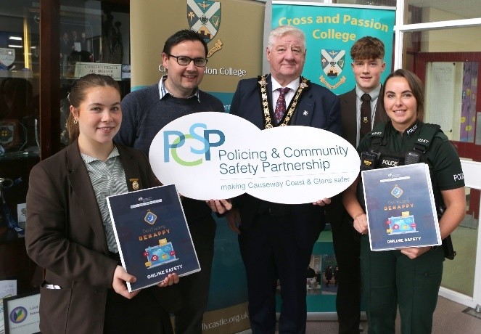
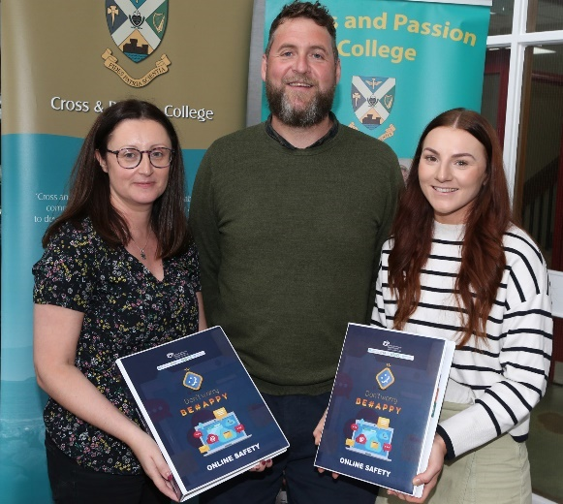

·

Please find the link for the resource and for each animation videos below:

https://view.pagetiger.com/online-safety-and-mental-health
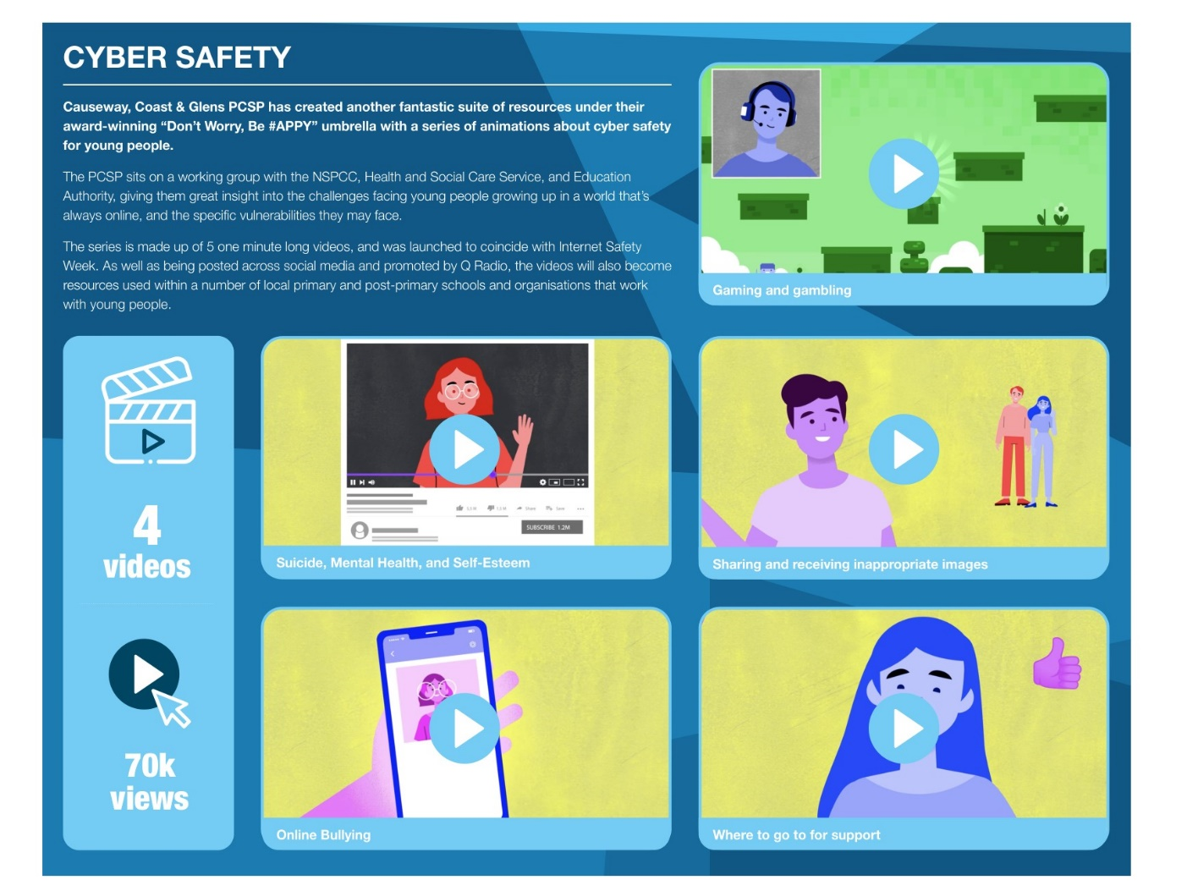

Suicide, Mental Health, and Self-Esteem - https://vimeo.com/510693667

Online Bullying - https://vimeo.com/512437054

Gaming and gambling - https://vimeo.com/515040080

Sharing and receiving inappropriate images - https://vimeo.com/518125676

Where to go to for support - https://vimeo.com/520867779

Theme 6: Vulnerabilities from Organised Crime inc Paramilitary

Community Intervention Support Programme
Developing Positive Engagement:
In 2022, the partnership identified a gap in the services for 18+ year olds, who are not eligible for Probation board or Youth Justice Agency funding. This project is designed to address individuals who are on the cusp or already at the attention of Police for intervention via individual grants programme (up to £600 each) to attempt to steer the individual away from Police attention. These individual grants will be interventions such as training courses, gym membership, etc whatever the individual has identified as a way of intervention from the behaviour they have been involved in or portraying, to avoid coming to the attention of Police. This project was proved successful and repeated to help more people in 2023.

AIMS Project based at Ulidian Centre, Ballymoney was the successful winning tender in 2022 and then again in 2023 to provide the management of the Developing Positive Engagements programme.

Feedback from AIMS:

This programme has benefited 24 young people and had an indirect positive impact on many more.

We would like to thank PCSP Members Steven Chambers, Caroline White and Chair Cllr. Ivor Wallace for their guidance and support throughout this programme.

As with previous participants on the DPE Programme, the majority of these participants had low self-esteem and struggled with anxiety and/or poor mental health.

We wish to thank PCSP for their forward-thinking in developing a personalised youth intervention programme and for trusting us to deliver it. The impact the programme has made on individuals is enormous, life-changing and must not be underestimated.

How much did we do?
192 Support meetings
24 all referrals
24 good news stories – 3 documented (below)

How well did we do it?
24 actions or interventions now completed
24 accepted
7 not accepted & sign posted elsewhere – 5 due to being under 18 & 2 as other funding available (The Personal Learning Account Grant)
100% partner satisfaction

Is anyone better off?
100% of persons referred show a decrease in incidents involving them since accepted on to programme
88% (21) of persons given interventions who achieved their goal (100% by end of 2024)
12% (3) are continuing to make progress to their goals, due to the type of intervention they chose which is over longer periods of time

Participant 3

The participant has, through their own admission, been involved in numerous anti-social driving offences. Their car was fitted with a modified exhaust, which caused excessive noise when being driven. The car's suspension had also been modified, which led it to be taken to the Vehicle Test Centre for examination for roadworthiness. The participant has been spoken to by police and felt the need to “be mouthy to them to keep up appearances” when in company.
The participant was in temporary part-time employment within the hospitality industry, and the intervention provided involved training within the security industry. As a result, the participant is now in full-time employment and keeps away from antisocial behaviour as they are too busy and do not wish to lose their professional security licence.

Participant 9

This participant had become embroiled with a group of football fans involved in acts of anti-social behaviour through scuffles with rival groups of supporters. Alcohol played a massive role in their behaviour at the matches. They have a certain amount of 'street credibility' whereby others look up to them and follow their lead. They are in part-time employment on a zero-hour contract, and lives with their partner and infant child. The participant is tired of this lifestyle but finds it difficult to walk away as the others are their friends and they feel if they move on, they will lose everything.
The participant attended an accredited event stewarding course, a 3-day first aid course, an Anti-Social Behaviour course and an Active Citizenship Course. This helped give them the opportunity to move away from the group and their involvement in acts of anti-social behaviour and involvement in minor scuffles. It gave them an understanding of the impacts of ASB and how they should interact with other communities. As they are a person of influence within their group, the intervention may help influence others to train as event stewards and to take a more positive role within society. The participant is now supporting small community events through voluntary work and determined to make their family proud.

Participant 18

The participant is a member of the LBGT community, and has found their sexuality difficult to come to terms with since their teenage years. They recently became involved in a steady relationship for the first time, however, when out with their partner in public, they became the target of unwanted and hurtful comments from the public. This led to anger issues and a mental health breakdown. Due to issues at school, they unfortunately left with very few qualifications, and find it difficult to gain employment, particularly as they feel so self-conscious about themselves. They wanted to gain qualifications in computing as they have an interest in computer science but cannot afford a computer and a course. The intervention enabled him to purchase a computer and do several free online courses through NRC and Ulster University. They really loved the flexibility of the courses and the content, and this has helped raise their confidence to the point of them enrolling with Open University on an accredited learning programme in the area of computer science.

Feedback from some participants:

“This will make a huge difference to me and I don’t miss those I used to run about with. I’m happier, more than I thought possible”.

“This has been a real lifeline for me and a huge wake up call. I was sleepwalking myself into serious trouble. So, thank you so much for all your help”.

“I have been offered a job! The first in my life and I promise to give it 100%. Thank you for believing in me and paying for a course I never could have afforded myself, I won’t let you down”.

“I now have 2 addictions, thanks to the PCSP. They are healthy eating and physical training. I have lost weight but gained new friends. I feel I have a purpose in life, no need to play the joker anymore as I am confident in my own self”.

A point of note: for the majority of participants, the behaviours they exhibited and became involved in were a reaction to mental health issues, lack of confidence, anxiety and a desire to fit in. This highlights the need for early intervention positive mental health and resilience programmes which may reduce these ‘cries for help’.

Causeway Coast and Glens Multi-agency Support Hub

Background

Vulnerable people living across the Causeway Coast and Glens are benefiting from the multi-agency support hub launched in February 2018, it encourages an ethos of working together to provide appropriate assistance to those in need. The initiative which involves Causeway Coast and Glens Borough Council, the Department of Justice, PSNI, Housing Executive, Northern & Western Health Trusts, NIFRS, NIAS and other statutory agencies on an ad hoc basis, was developed as part of the Community Plan for the area which provides a long-term vision for the future based on needs, priorities and opportunities.
The multi-agency approach of the Support Hub helps to create a fuller picture around the person or family unit allowing for early interventions to reduce vulnerability and improve well-being. Information sharing between the partners means individuals and groups are getting the right help for their particular circumstances.
Since February 2018, over 200 people have been helped in a number of ways. Some have been supported directly by agencies in the Support Hub others have been signposted to local support groups. In some cases the statutory bodies have worked together to prevent perpetrators from getting access to vulnerable individuals. The Support Hub is partnering, where appropriate, with other groups throughout Causeway Coast and Glens in order to help as many people as possible. In 2023 we achieved the following outcome:

How much did we do?
11 Meetings

How well did we do it?
34 referrals agreed

Is anyone better off?
23 individuals supported

Evaluation of Support Hubs in Northern Ireland
https://www.justice-ni.gov.uk/topics/evaluation-reports

Winter Well Events

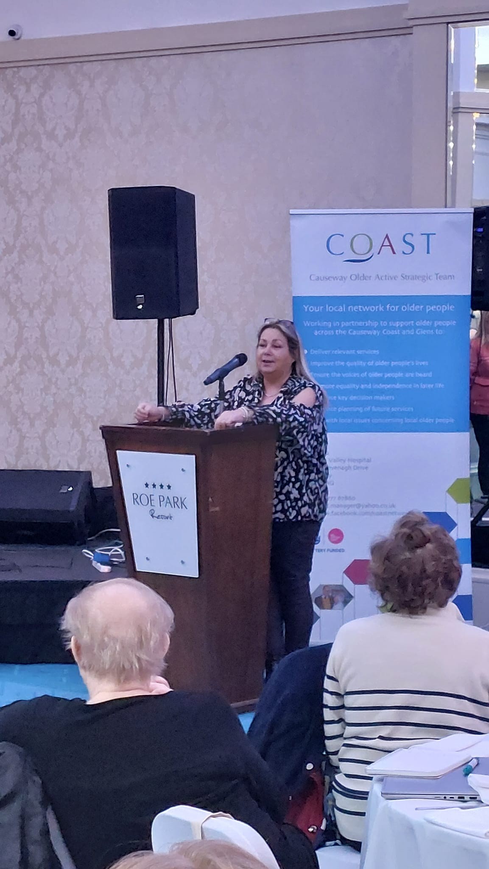
How much did we do?
4 Events
625 Attendees at the events
4 Different towns hosting events

How well did we do it?
100% Attendees finding event useful
20% Attendees new

Is anyone better off?
625 and 100% participants who believe they learned about: The likelihood of being a victim of crime
How to contact the police or other support services
100% People more likely to report crime to the police
These events allow the PCSP to engage with a large number of people at once. Bringing together a range of services and agencies that can help and advise the senior community. We worked in partnership with a range of different organisations to implement this programme. Using the PSNI Crime Prevention officer, PHA, HSC, Good Morning services, LDCI, BCRC as well as COAST and other best place organisations to advise communities on their local needs.
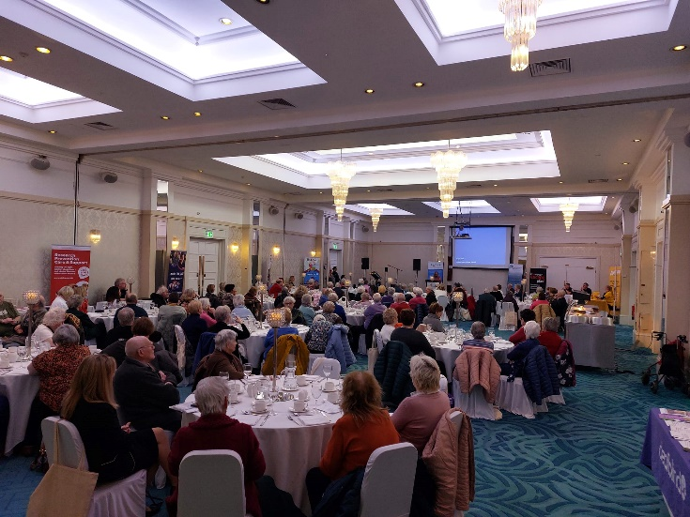

Safe Home Scheme

Safe Home is a multi-agency partnership project whereby police refer victims of crime and those who are vulnerable are referred by social workers, family members, older persons groups as well as self-referrals.

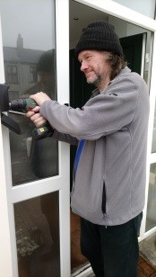
Safe Home has beneficiary selection criteria to ensure that the service is targeted at the most vulnerable. The project is delivered by Causeway Older Active Strategic Team (C.O.A.S.T) across the council area.
The project is delivered via a bespoke home visit where an assessment is undertaken in respect of security needs and participants have the opportunity to have appropriate equipment installed. 275 completed visits with 100% of those vulnerable or isolated people that have received this service, feel it has had a positive impact on their lives. This has given them the confidence to feel safe in their own homes.

Key Safes
To date COAST has fitted 500 key safes for the PCSP -

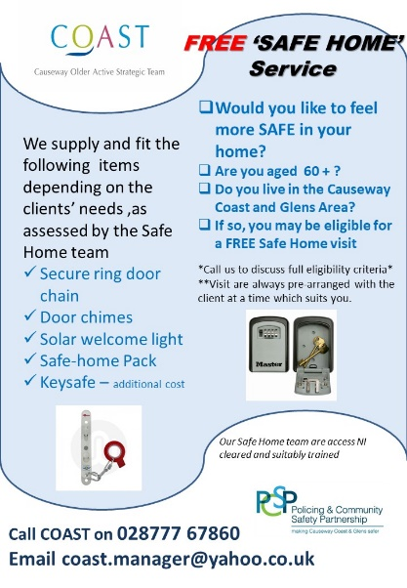

Disability Project

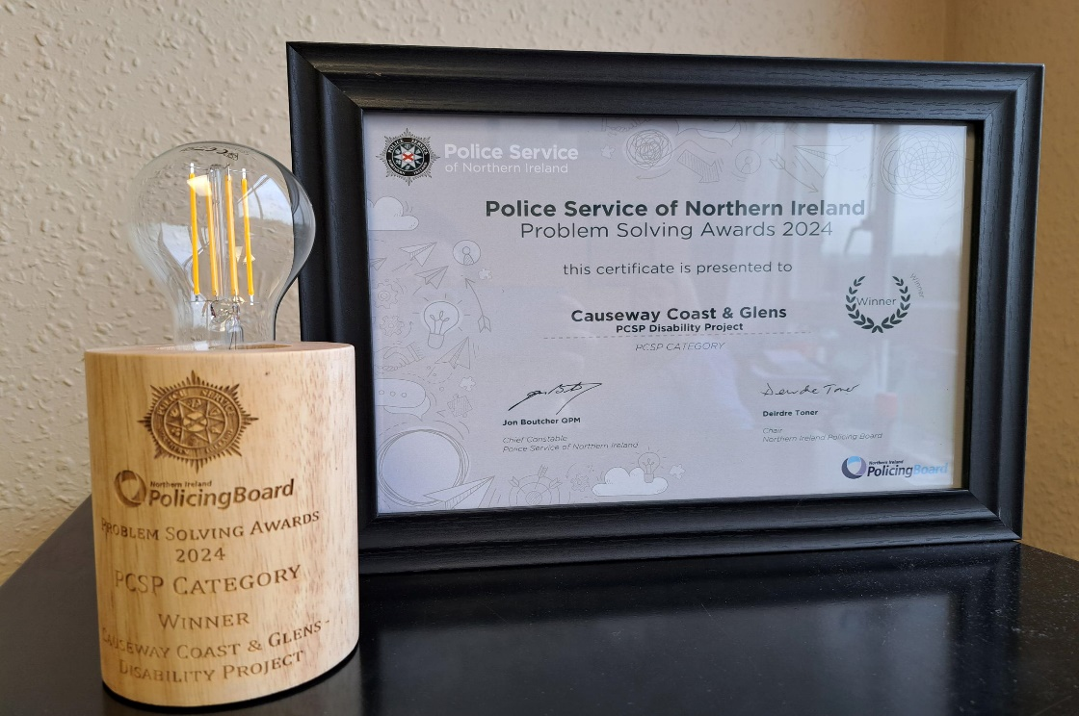

The PCSP worked closely with the PSNI, local disability charities (Disability Action, Mencap Autism NI and Causeway Neurodiversity), and the Hate Crime Advocacy Service to plan and develop a disability hate crime awareness raising project, with a particular focus on young people.
A recent PCSP consultation highlighted that people living with a disability said they would feel safer if others were more educated about disabilities while 63% of carers said that increased education and awareness about disability hate crime is needed.
Over the last 2 years, the PCSP has hosted training courses on Makaton and Learning Disability Awareness with participants gaining a better understanding of the needs of others. The PCSP are also keen to encourage society to speak out against Disability Hate Crime, and support those affected to report what has happened to them.
Through a PCSP consultation, it was clear that that many people with disabilities would feel safer if their needs were better understood so there is a clear requirement for increased education and awareness raising.
The PCSP and partners agencies wanted to highlight what disability hate crime is, the impact it can have, where to find support and how we all have a role to play in helping others live peacefully without fear. In 2022 an awareness raising animation was created. This can be found on:
Vimeo - https://vimeo.com/811246149

You tube - https://youtu.be/MFb3cjqAqN4

In 2023 the PCSP along with partners agencies engaged with another disability hate crime organisation in Scotland and as a result have developed a lesson plan for use in schools and youth settings. The lesson plan is due to be launched during 2024 hate crime awareness week.

The PCSP also worked closely in 2023 with the Council’s Good relations team to plan develop and organise a living library event called Who are WE? Which took place during hate crime awareness week in October 2023. This event enabled members of the public to come and listen to the lived experience of people from a range of diverse backgrounds and hear about how experiences of hate crime impacted them. Attendees also had the opportunity to ask questions to speakers and support agencies find out how to access support.

The Causeway Coast and Glens PCSP’s disability project was the winning project in PCSP category of the PSNI Problem Solving Awards.

Who are We? Living Library Event (Joint Project with Good Relations)

How much did we do?
One hate crime living library event arranged for Oct 2023 in partnership with Council Good Relations

How well did we do it?
100% satisfaction with participants of the project

Is anymore better off?
100% of participants had progressed to a greater degree of knowledge of what is hate crime by the end of the event.
Eg: Only 13% had a great deal of knowledge before event & this increased to 53% at end of event.
94% of attendees reported they increase knowledge on how to access support. 5% neither agreed or disagreed that they had gained more knowledge on how to access support

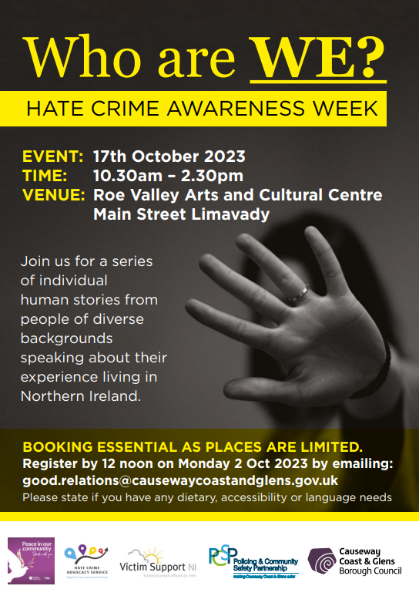

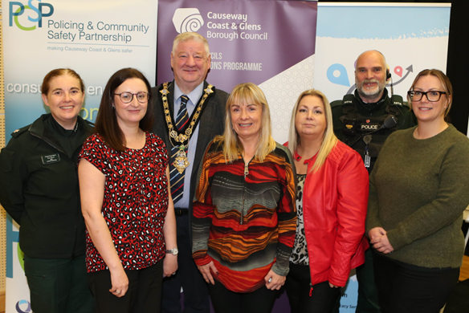

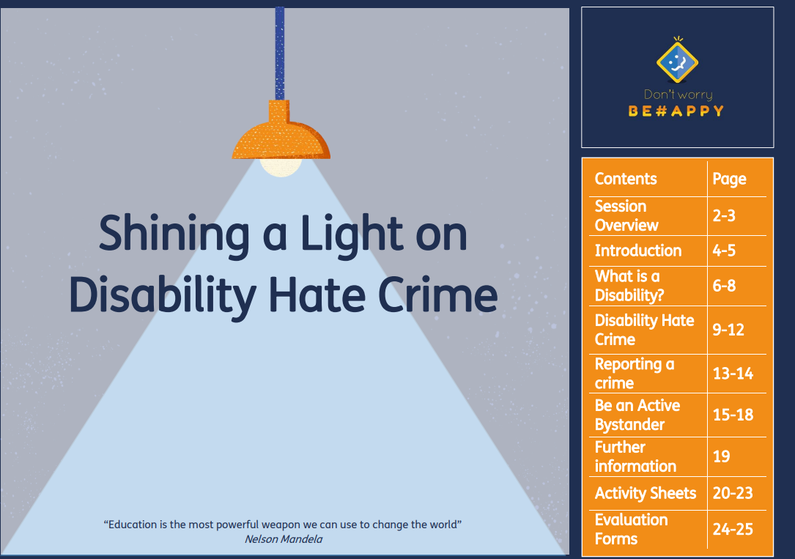

LESSON PLAN
How much did we do?
Development of Disability Hate crime lesson plan (consisting of animation, workbook, presentation and lesson plan guidance)
How well did we do it?
100% partners satisfied with content and layout of lesson plan.
100% young people who participated in testing phase of lesson plan were satisfied with the content.
Is anyone better off?
100% young people trialling the lesson plan increased their knowledge of what is a disability hate crime.
100% of the young people involved in trialling the lesson plan learnt how to access support
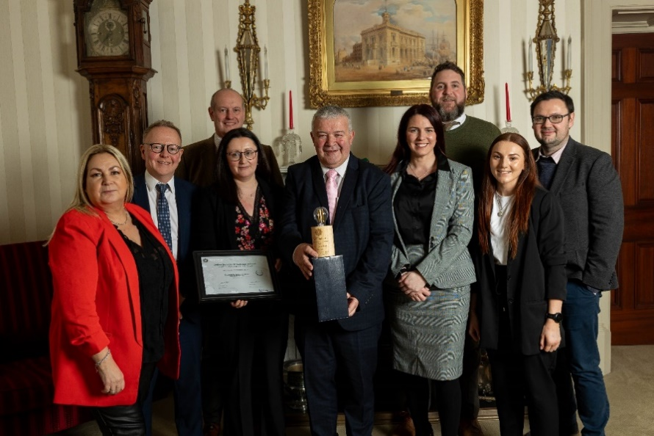

Pictured at PSNI Problem Solving awards – Causeway Coast and Glen PCSP and partners. Winners of PCSP category for Disability Project.

Crime Prevention

The PCSP provided crime prevention equipment to the Crime Prevention Officer who carried out an average of 12-14 weekly visits (Visits varie from domestic abuse victims, older persons, housebound, victims of crime and people feeling vulnerable to crime).

Items were also provided to members of the public through PCSP member community engagement activities. Members of the PCSP attended many community events to highlight their role as PCSP members and listen to community concerns around policing and community safety. They also took the opportunity at these events/meetings to distribute crime prevention items and literature.

A crime prevention information roadshow was held in July 2023. PCSP representatives, the local crime prevention officer and local neighbourhood policing officers hosted information stands across the Borough during the week commencing 3rd July in various supermarkets and in the Causeway Hospital. The high footfall of such locations meant that PSCP and PSNI were able to engage with many members of the public sharing crime prevention advice, information and practical resources (personal alarms, fraud rollers, RFID cards, Purse chains etc).

As part of the Crime Prevention Project Causeway Coast and Glens Policing and Community Safety Partnership (PCSP) also held two crime prevention training sessions in Portrush and Ballymoney on Tuesday 12th March.
The well attended training sessions offered residents of the Causeway Coast and Glens Borough the opportunity to learn more about the Principles of Crime Prevention Principles, the appropriate security products for residential settings, how to carry out an effective home security survey and information on cold calling and current scams.
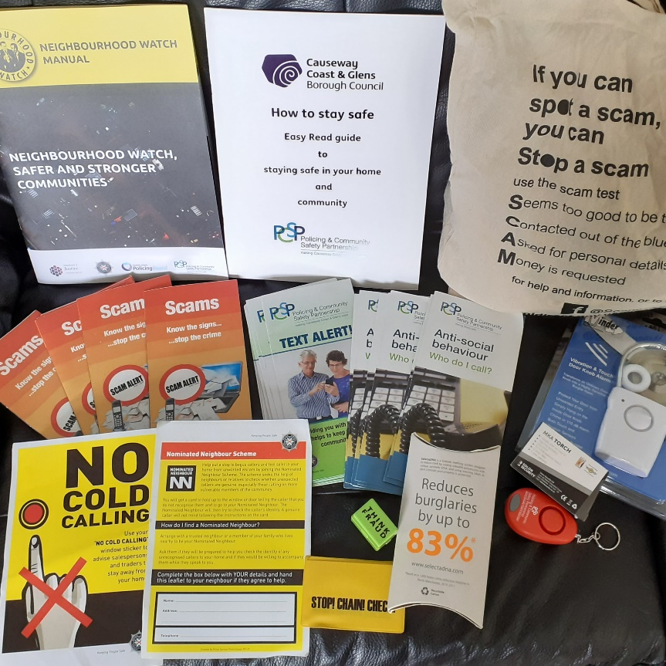

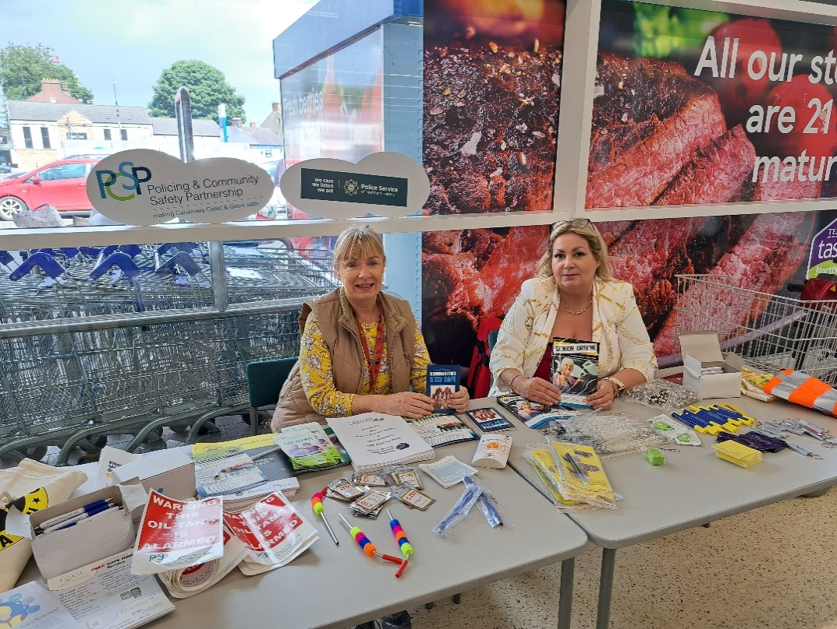

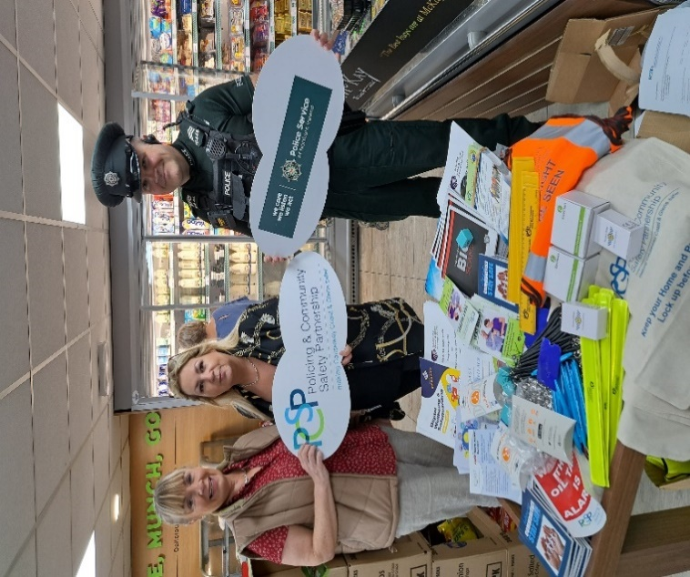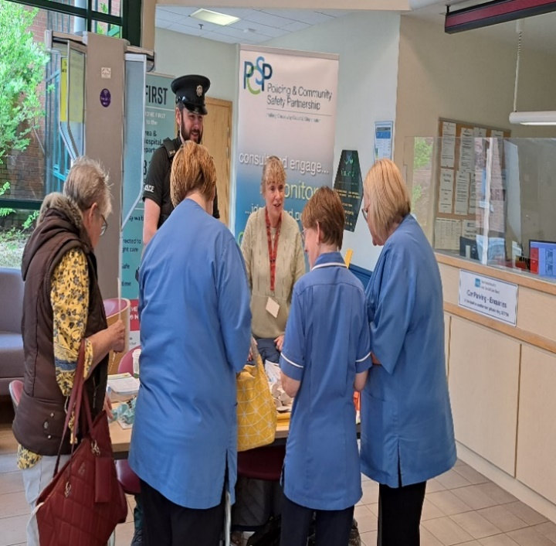
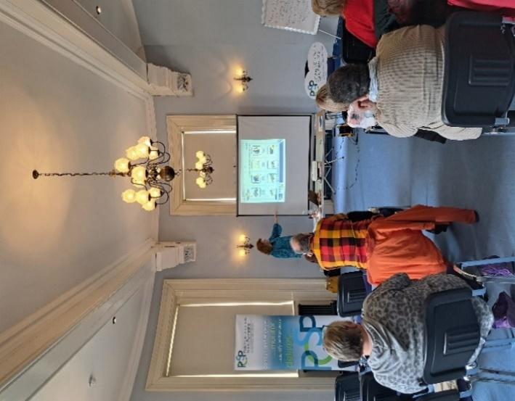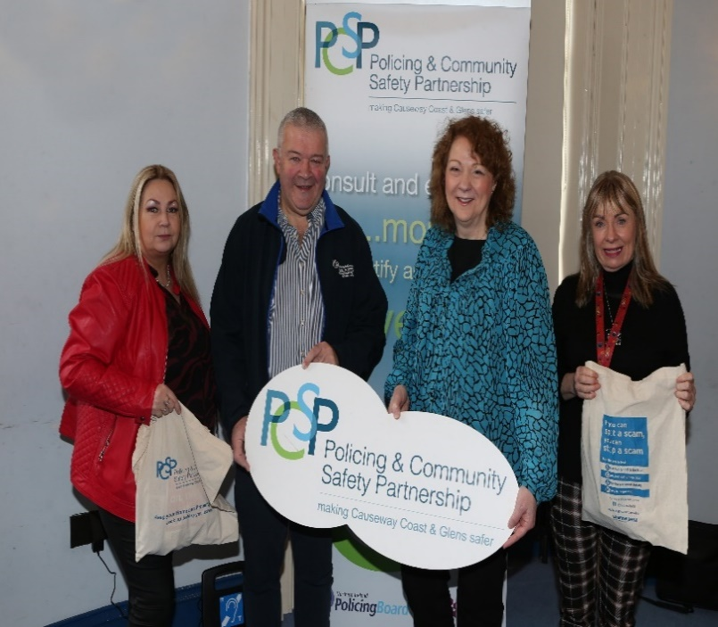

How much did we do?
8 crime prevention events including PCSP members hosting stands with CPO, trailer marking and 2 crime prevention training sessions*
11 residents completed CPI crime prevention training
1000+ crime prevention items issues
How well did we do it?
100% users felt that the event/training and equipment was useful

Is anyone better off?
84% of attendees who have adopted the crime prevention advice.
96% participants reported increased knowledge of the work of PCSP following event.
88% participants with increased confidence in PSNI following event.
86% participants more likely to report crime following event.
100% increased knowledge in crime prevention.

Strategic Objective 3 - to support community confidence in policing- includes the work carried out on the Policing Committee and a number of causeway wide campaigns.

PCSP Grants

PCSP offered a £999 grant in 2023/24.

The PCSP small grants programme has been developed to provide organisations with up to a £999 grant to organise a project or event that will help prevent, reduce, address crime and help people feel safer in their own communities.

To encourage groups who have never applied for funding from PCSP, groups were asked to answer the following questions:

Q1 What is your project/event?
Q2 How will it help prevent, reduce, address crime and help people feel safer in your community?

By simplifying the bureaucracy the Partnership received applications from across the Borough and for a wide range of events/projects.

No. of applications received | 64
No. of ineligible and unsuccessful applications | 21
No. of successful applications | 43
Total value/expenditure for grant programme | £ 41,154.85

GROUP | DESCRIPTION | AMOUNT | New group to PCSP
AGE Concern | Dementia Safeguarding Scheme | £999.00
Mothers Union | Care of elderly security anti-scamming | £996.00 | Yes
Roe Valley Ancestorial Researchers | Introduce country practices in Farlow Wood | £999.00 | Yes
Ballymaconnelly Renewal Group | Prevention of vandalism and restoring community confidence | £999.00 | Yes
Angel of Hope Memorial Garden | CCTV | £999.00 | Yes
Zachary Geddis Trust | Male defense classes | £960.00
John Mitchels GAC Glenullin | Community safety in rural Glenullin | £999.00 | Yes
Leaney PS PTA | Creative mindfulness | £979.00 | Yes
Ballycastle Orange Lodge | Young person entertainment 12th July | £975.00 | Yes
BBT | A safer community | £999.00
West Bann | Street beat - clean up and artwork at Andersons Park | £999.00
Articlave DCA | Supporting our seniors | £999.00 | Yes
Ballyspallen Cricket Club | Sport youth diversionary | £863.40
St Patricks School PTA Rasharkin | Youth sport diversionary | £999.00 | Yes
Mosside Educational Rural & Cultural Society | Community safety info sessions with PSNI | £999.00 | Yes
Be Safe Be Well | Bike Safe | £988.00
Ballysally Presbyterian Church | Lights | £999.00 | Yes
St Mathews GAC Drumsurn | Walking track lights | £999.00 | Yes
Ballycastle Com Hub | Security system | £999.00 | Yes
Millburn Community Assoc | Community Youth Hub | £479.00
Portstewart Regeneration & Cultural Group | Domestic abuse awareness via podcasts from survivors | £999.00 | Yes
Mother Goose Playgroup | Hi Vis and road safety | £999.00 | Yes
Mosside Band | Youth diversionary | £999.00 | Yes
Dunseverick Accordion Band | CCTV | £996.37
Heart of the Glens | LED reflective sashes x 140 | £999.00 | Yes
Causeway Giants American Football Club | Cameras to deter ASB driving on the pitch | £990.00
Causeway Sports Academy CIC | Half term football camp sports diversion | £949.88 | Yes
Causeway Assoc of Urban Sports | Skatepark ramps for youth in Portrush to reduce ASB | £999.00 | Yes
Street Doctors | Reducing violence programme including what to do in emergency | £990.00 | Yes
Ballymoney Evergreen Club | Social Centre security cameras | £999.00 | Yes
Cushendall Dev Group | Social Centre security cameras | £999.00 | Yes
Friends of Castlecatt War Memorial Hall Assoc | Social Centre security lighting | £999.00 | Yes
Donegal Derry Vipers American football club | Community youth engagement | £999.00 | yes
Glebeside Com Assoc | Knitting group | £985.00
Dalriada Training | Takes a village to raise a child | £995.00
Royal British Legion Aghadowey | Workshops on drugs and child protection | £999.00
Kilrea & District Ulster Scots Society | Crime prevention with dinner | £999.00
Tullaghmurry Fold | Sensor lights, CP talk and dinner | £925.00
Windyhall 50+ club | Crime Prevention talks with dinner | £961.20
Boveedy Springwell Club | Crime Prevention talks with dinner | £999.00
St Canices GAC | Outreach work - jackets hi viz | £975.00 | yes
Destined ltd | 4 week crime prevention safety talks to adults with learning difficulties | £980.00 | yes
PSNI | REAL event - room hire and catering | £280.00

How much did we do?
43 of grants issued
64 of applications

How well did we do it?
100% groups delivering their grant programme
3055 of people engaged through the grant programme

Is anyone better off?
100% groups showing positive outcomes
100% groups reporting greater confidence in identifying and delivering community safety outcomes by themselves
87%participants with increased confidence in PSNI following event

The 43 groups issued with a £999 grant produced the following results:

How much did we do?
61 of workshops/sessions/training/events/talks/outreach
3055 of participants at workshops/sessions/training/events/talks/engaged in outreach
235 of Hi viz items distributed to local community.
7 of community safety videos/podcasts produced
48 of sport diversionary events/sessions/training
108 of youth diversionary events/sessions/training/talks/outreach
22 of security cameras funded to protect premises, users, property against ASB/Crime
36 of security lights funded to protect premises, users, property against ASB/Crime
1144 of security equipment distributed to local community

How well did we do it?
100% users feeling the service/event was useful
100% of users who felt the equipment was useful
96% of attendees satisfied with quality of event/training session
96% people satisfied with the experience
100% of attendees of project who found PCSP members engagement useful at their event etc

Is anyone better off?
98% participants feeling safer as result of workshops/sessions/training/events/talks/engaged in outreach
83% participants increased knowledge of the work of the PCSP
94% participants more likely to report crime following event.
100% increased knowledge in crime prevention
100% attendees with increased knowledge topics covered in the workshops/sessions/training/events/talks/engaged in outreach
100% who learned about access to other supports
100% of users who felt safer because of the equipment
100% participants reporting learning new information
100% of participants giving increased thought to the consequences of risk-taking behaviour.
78% of participants more likely to engage with the PSNI
100% of group members with greater confidence in identifying and delivering community safety outcomes/projects
78% participants with increased confidence in PSNI following event

Millburn Community Association

“Seeing out youth working and building new relationships with children from the Heights area was a fantastic thing and in such a short time our Youth Provision in Millburn has took off and continues to engage with the children”

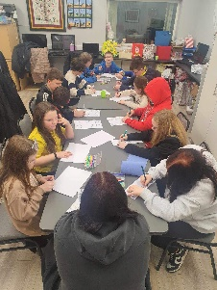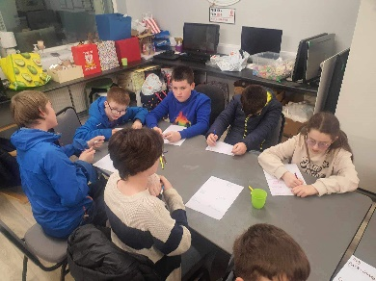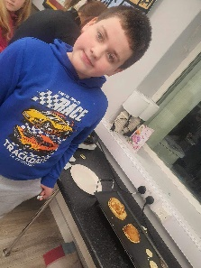
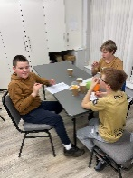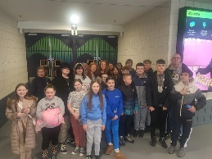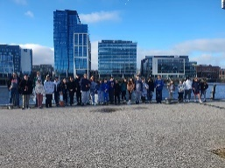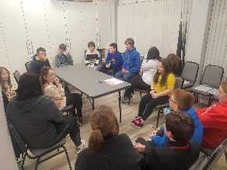

Be Safe Be Well

Portstewart Mens Shed Staff and members have launched an upcycling project which aims to provide all asylum seekers living in the Triangle area with a bicycle. The 'ReCycle' project has been financially support by the Good Relations Dept CCGC and supported by the 'LifeCycles project based in Derry

The not for profit project aims to rescue bikes from the waste stream, repair them, and pass them on to men, women and children living locally. Bicycles are the asylum seekers only means of transport other than walking. It is essential that they have some means of transport to attend medical appointments, access emergency/ support services and buy essentials for living here.

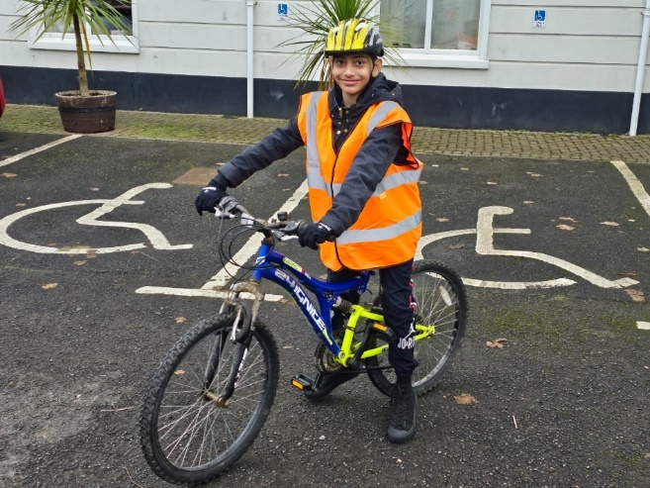
Mother of Raja, the boy pictured above.
‘ I want to thank PCSP for giving my son the safety equipment for his bike. I was worried that he was going to get hurt when he rode his bike on the roads without them.’

Dalriada Training Services C.I.C. – “It takes a village to raise a Child”

“It was great to see the community coming together to support this project and the sense of pride within the whole community as the videos are being released of the young people interviewing local people”.

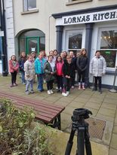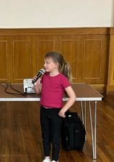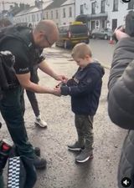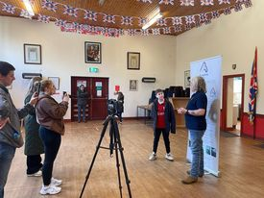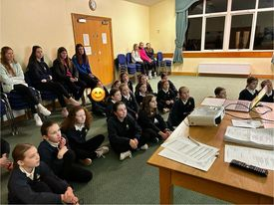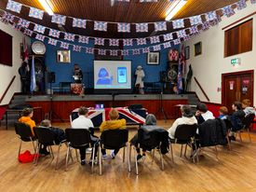

Confidence in Policing
We are currently working with the PSNI to increase awareness and also confidence in policing. Over the year we had 11 Policing Committee meetings, community consultations (surveys, public mtgs & community consultations). We hope to develop this work in 2024/25 to help improve policing for everyone.

Policing Committee
The Policing Committee met monthly to monitor police performance. The Committee ensured that local views were being taken into account when producing the Policing Plan for Causeway Coast and Glens area. Community views were received in the following ways:
- PCSP Members
- PCSP Meetings
- Social Media
- PCSP Events and projects as indicated above
- Neighbourhood Watch Clinics
- Funding Roadshows
- Support Hub

Campaigns:
A number of campaigns have taken place through the year.

- Dangerous Driving on the beach
- Radio advert promoting the work that CC&G PCSP do in the council area.
- Domestic violence campaign, Social Media Campaign
- Drink and Drug Driving radio advert and Social Media Campaign
- ‘Speeding’ Social Media Campaign
- ‘Using your mobile phone while driving’
- ‘Awareness of Agricultural vehicles on our roads’
- Cyber Safety.

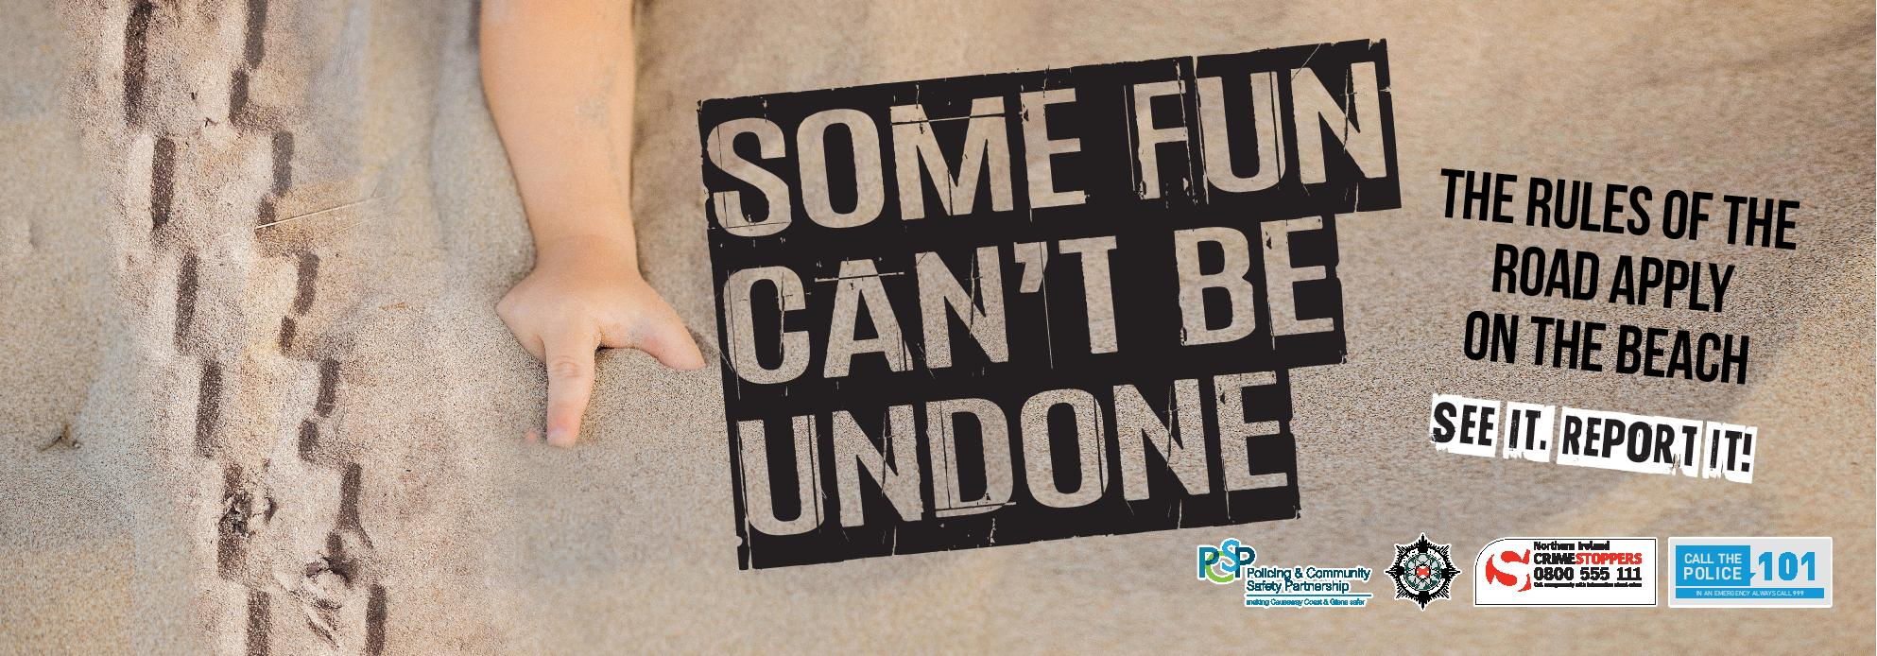
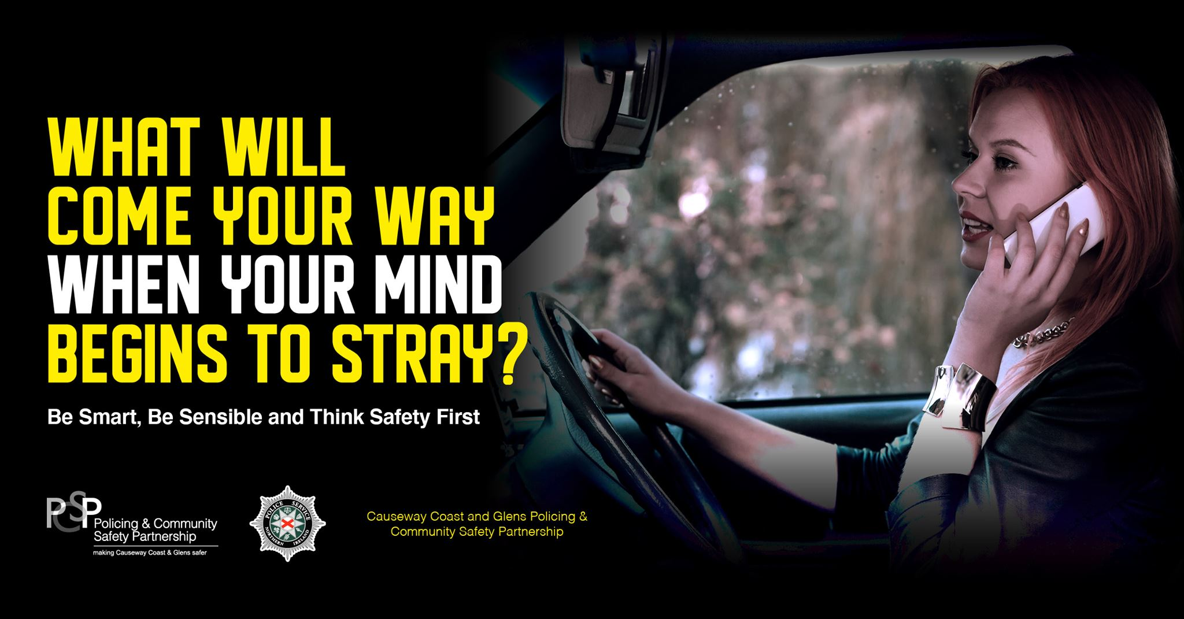



Text Alert Scheme
Text Alert continues to expand Borough wide. It is a free service available to anybody aged over 18 years of age who is a resident of, or has property located in the Causeway Coast and Glens Borough Council area. Community safety information is sent by a PSNI Officer or PCSP staff to a registered member of the scheme via a SMS text message to their mobile phone. The information will be specific to the area where they live, or relevant to their type of business or where they have property located e.g. a caravan on the coast. Residents of towns and villages for example may like to receive quick and up-to-date information if there has been a spate of break-ins or thefts in their locality, or if there is known bogus callers in the area, or if a traffic collision has caused a road closure.

Text Alert is an important addition to the community safety services that are provided. It is a simple but very effective way of sharing information. (To join the scheme you must first complete a registration form and provide the mobile number through which you would like to receive community safety text messages. Follow link to register - https://www.causewaycoastandglens.gov.uk/live/policing-and-community-safety-partnership/pcsp-text-alert-scheme or to obtain a registration form please use contact details at the back)

PCSP and Community Planning
Planning is one of the key responsibilities of local government and it requires Council ‘… to initiate, maintain, facilitate and participate in community planning Community for its district.’ The purpose of community planning is to develop a long-term vision and plan for the Causeway Coast and Glens Borough area and all its citizens based on thorough analysis of needs, priorities and opportunities to address them.

As the key delivery mechanism for Community Safety, the following two initiatives are included in the Delivery Plan for Causeway Coast and Glens Community Plan
2017 – 2030:

Action 11
POPULATION OUTCOME: All people of the Causeway Coast and Glens will contribute to and benefit from a healthy, connected and safe community that nurtures resilience, promotes respect and supports everyone to live well together
OUTCOME 4: The Causeway Coast and Glens area feels safe

ACTION 11 | IMPLEMENTATION  MILESTONES |  | LINKAGES ACROSS PLAN | PARTNERS | TIMEFRAME  S / M / L
To establish and facilitate a multi-agency Support Hub to monitor and evaluate effective information sharing, enable focused decision making for early intervention and appropriate actions to be taken to reduce the vulnerability of individuals and the risk for victims and their families and as a result increase public safety. | - Engage Partners (Jan 2018)  - Develop information sharing protocols  - Agree meeting schedule | This means that:-  4.1: People in CC&G experience a reduction in levels of crime  4.2 The people of CC&G benefit from a reduction in fear of crime  Also LINKS to:-  Outcome 2:- Our children and young people will have the very best start in life |  | ACTION LEAD ORGANISTION  Causeway Coast and Glens Borough &  Police Service of Northern Ireland  PARTNER ORGANISATIONS:  - CC&G BC  - PSNI  - PBNI  - YJA  - NIHE  - EANI  - CCG BC  - NIFRS  - NHSCT/WHSCT | M
PERFORMANCE INDICATORS FOR THIS ACTION | BASELINE 2017 | TARGET |  | LEAD OFFICER FOR PERFORMANCE MEASURES | TIMEFRAME  S / M / L
- Establish hub  - Agency Representation  - Number of meetings  - Information shared & actions agreed  - Outcomes for individuals-reduced vulnerability | Zero – new initiative | Establishment of Support Hub for CC&G |  | PCSP Manager | M

Action 12
POPULATION OUTCOME: All people of the Causeway Coast and Glens will contribute to and benefit from a healthy, connected and safe community that nurtures resilience, promotes respect and supports everyone to live well together
OUTCOME 4: The Causeway Coast and Glens area feels safe

ACTION 12 | IMPLEMENTATION  MILESTONES | LINKAGES ACROSS PLAN | PARTNERS | TIMEFRAME  S / M / L
To develop and deliver a digital Resistance / Cyber Safe - mapping exercise re: current activity and gaps - Partner Meeting (see list of partner organisations)  Agree priority themes e.g. cyber-bullying, grooming, scamming and priority areas aimed at all sections of community – young / old etc. | - Key organisations in the cyber-safety sector map current activities and identify gaps to be addressed  - Scope and Identify partnership based cyber-safe activities to fund / progress based on agreed priority themes  -Identify delivery agents and operational actions  (2017 / 18 budget for cyber-safety is £20,000) | This means that:- 4.1: People in CC&G experience a reduction in levels of crime  4.2 The people of CC&G benefit from a reduction in fear of crime  Also LINKS to:-  Outcome 2:- Our children and young people will have the very best start in life  Plan | ACTION LEAD ORGANISATION  Causeway Coast and Glens Borough Council  PARTNER ORGANISATIONS:  - NSPCC  - PSNI  - EA / CCMS  - Libraries NI  - PSNI  - NEXUS  - NHSCT/WHSCT  - YJA  - C&V Sector | S /M
PERFORMANCE INDICATORS FOR THIS ACTION | BASELINE 2017 | TARGET | LEAD OFFICER FOR PERFORMANCE MEASURES | TIMEFRAME  S / M / L
- Cyber safe activities mapped and gaps identified  - Partnership based outcomes focused cyber-safety project established and funded, reporting performance / progress directly to PCSP | No specific multi-partner outcomes-focused cyber-safety project currently operating Borough wide | An outcomes-focused multi-partner project that produces sustainable outcomes for children and young people vulnerable to and affected by different forms of cyber-abuse. | PCSP Manager  Jonny Donaghy | S / M

Quarterly updates are produced for the Community Planning Department and are available on request.

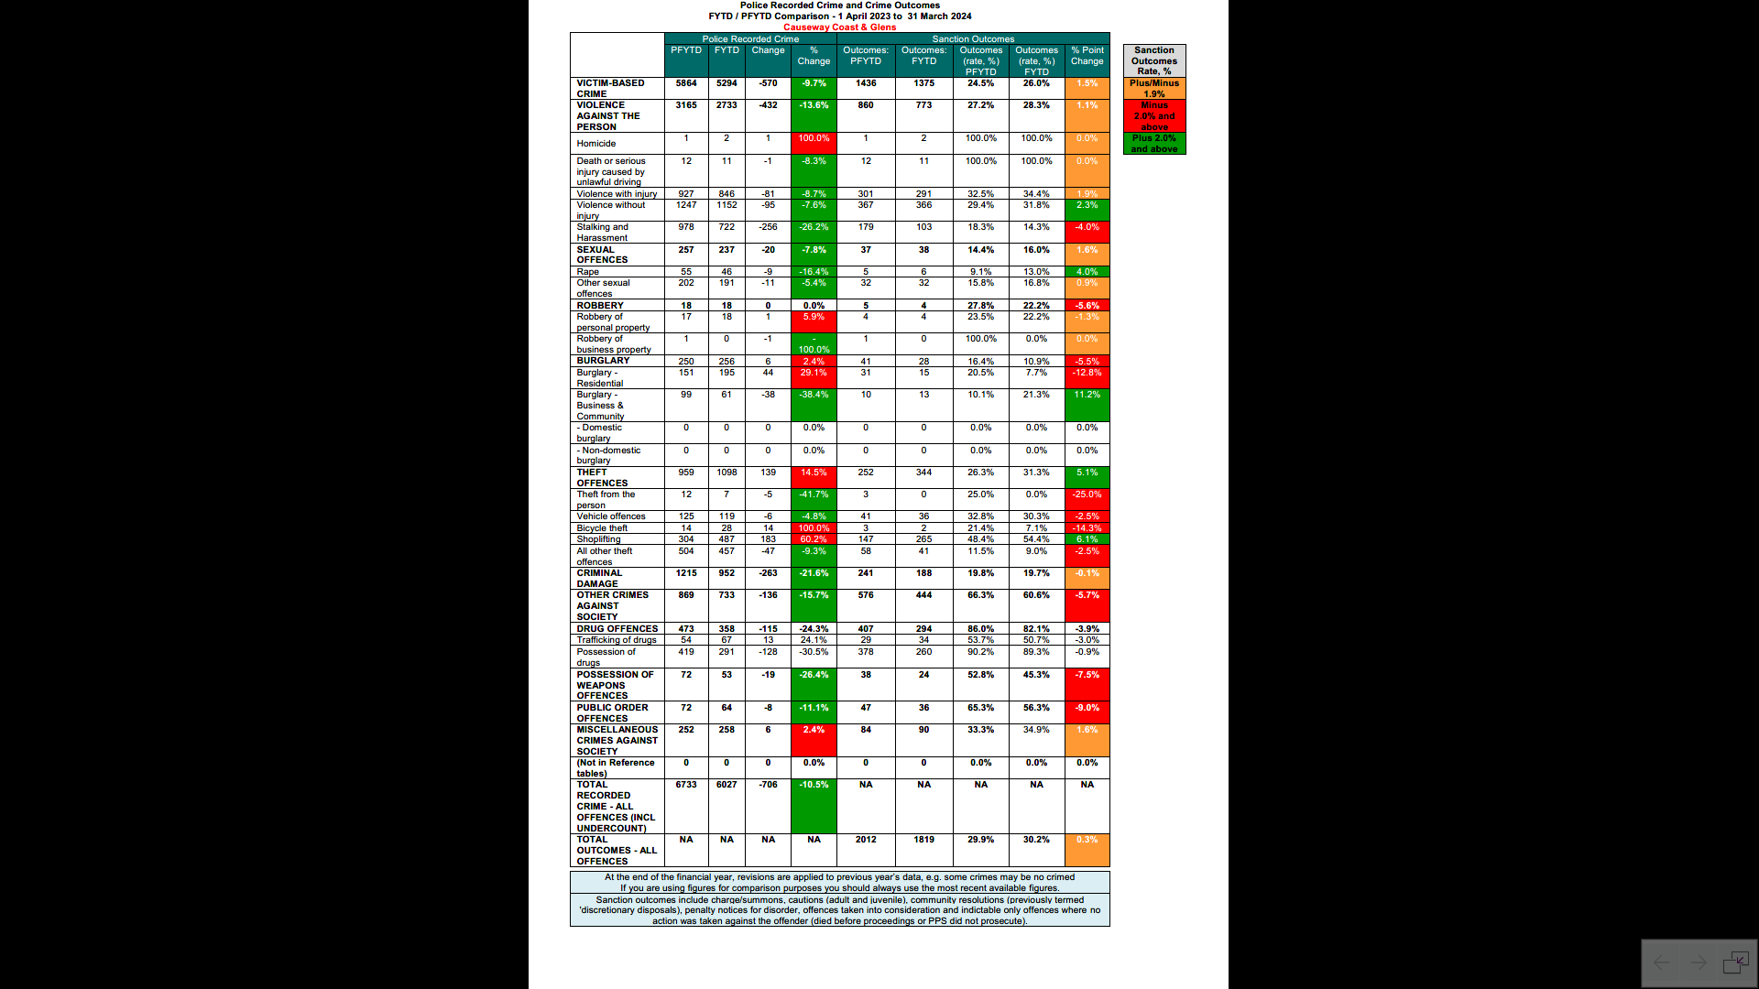

PCSP Financial Statement
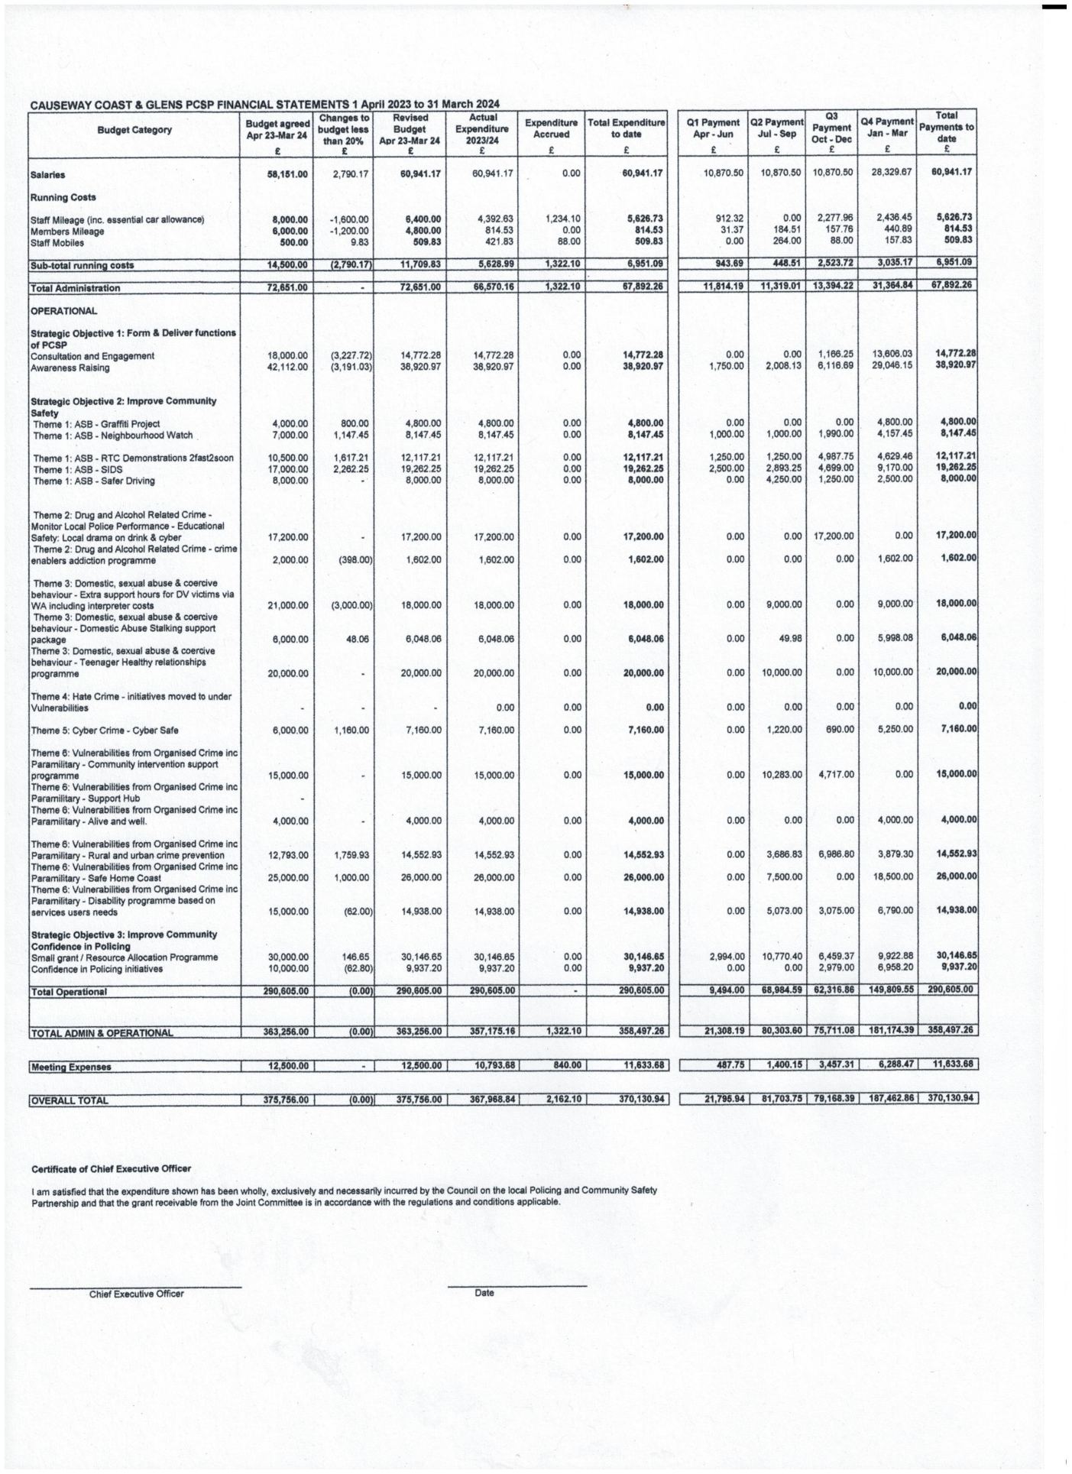

Contact Us

Causeway Coast and Glens PCSP

Tel: 028 7034 7034

Email: pcsp@causewaycoastandglens.gov.uk

Ballycastle: Sheskburn House, 7 Mary Street, BT54 6QH
Tel: 028 2076 2225

Ballymoney: Riada House, 14 Charles Street, BT53 6DZ
Tel: 028 2766 0254

Coleraine: Cloonavin, 66 Portstewart Road, BT52 1EY
Tel: 028 7034 7044

www.causewaycoastandglens.gov.uk

