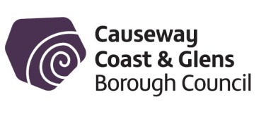
PeriodSmart

Reusable period products voucher application form

Please note: This scheme is only available to people living within the Causeway Coast and Glens Borough Council boundary.

Name: _____________________________________________________

Address: _____________________________________________________

Postcode: ______________________________

Phone Number: ________________________

Email Address: _____________________________________________

- I have purchased reusable period pants / liners / pads / menstrual cup as outlined in the terms and conditions with a minimum spend of £20 and have enclosed the itemised receipt(s).
- I have purchased reusable period pants / liners / pads / menstrual cup as outlined in the terms and conditions with a minimum spend of £40 and have enclosed the itemised receipt(s).
- I understand and accept the terms and conditions of the scheme.
(Please see overleaf).

Signed: _________________________________________ Date: ________________

Where did you hear about this scheme?

Please return this form to:
Environmental Resource Officer Team, Riada House, 14 Charles Street, Ballymoney
BT53 6DZ
or email to: recycle@causewaycoastandglens.gov.uk

Terms and conditions
- You must be a permanent resident within the Causeway Coast and Glens Borough Council boundary.
- Applicants must spend at least £20 on reusable period pants / liners / pads / menstrual cup to be eligible for a voucher worth £15 or £40 for a voucher worth £30.
- The voucher can be redeemed at Considered Co Zero Waste and Refill Store, 8A Stone Row, Coleraine, BT52 1EP. Original, itemised receipts(s), which include date of purchase, must be supplied to Council.
- Vouchers are available for purchases from 1 January 2024 onwards (must have receipt with date of purchase).
- Participation in the voucher scheme is considered to be a ‘one off’ and does not constitute any commitment to future support.
- A voucher will be arranged on a first come, first served basis.
- Only one voucher application per person will be accepted.
- Causeway Coast and Glens Borough Council will ask you to provide feedback.
- The scheme is subject to availability and may be withdrawn at any time.
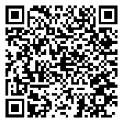
PeriodSmart is part of Causeway Coast and Glens Borough Council LiveSmart campaign. Scan the QR code with your phone’s camera and click on the link to find out more.
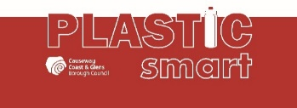

Privacy Notice:
You can, at any time, request for your details to be updated or deleted. Please contact
recycle@causewaycoastandglens.gov.uk

As a public authority, Council takes your rights and freedoms seriously and will only release information when required under law or with your consent. Further information about your rights, how long information is held for, or how to contact the Data Protection Officer can be found at: https://www.causewaycoastandglens.gov.uk/live/bins-and-recycling/privacy-notice

